D. Student Guide: ResponseWare App and Web Login

ResponseWare is a product from Turning Technologies that acts like a “virtual Clicker for mobile devices.” It is available for Android, Apple, and web browsers and, in courses where it is allowed, it may be used in lieu of a Clicker device. The tutorial below provides instruction for downloading the ResponseWare app for mobile devices. It also provides instruction for accessing ResponseWare via the web.

Warning: ResponseWare may ONLY be used if your instructor allows it. If you are unsure whether or not ResponseWare is allowed in a course, ask your instructor.

Downloading the ResponseWare App

For Android
- Open Google Play Store.
- Search ReponseWare ( it should be the only app with that name).
- Make sure it is created by Turning Technologies.
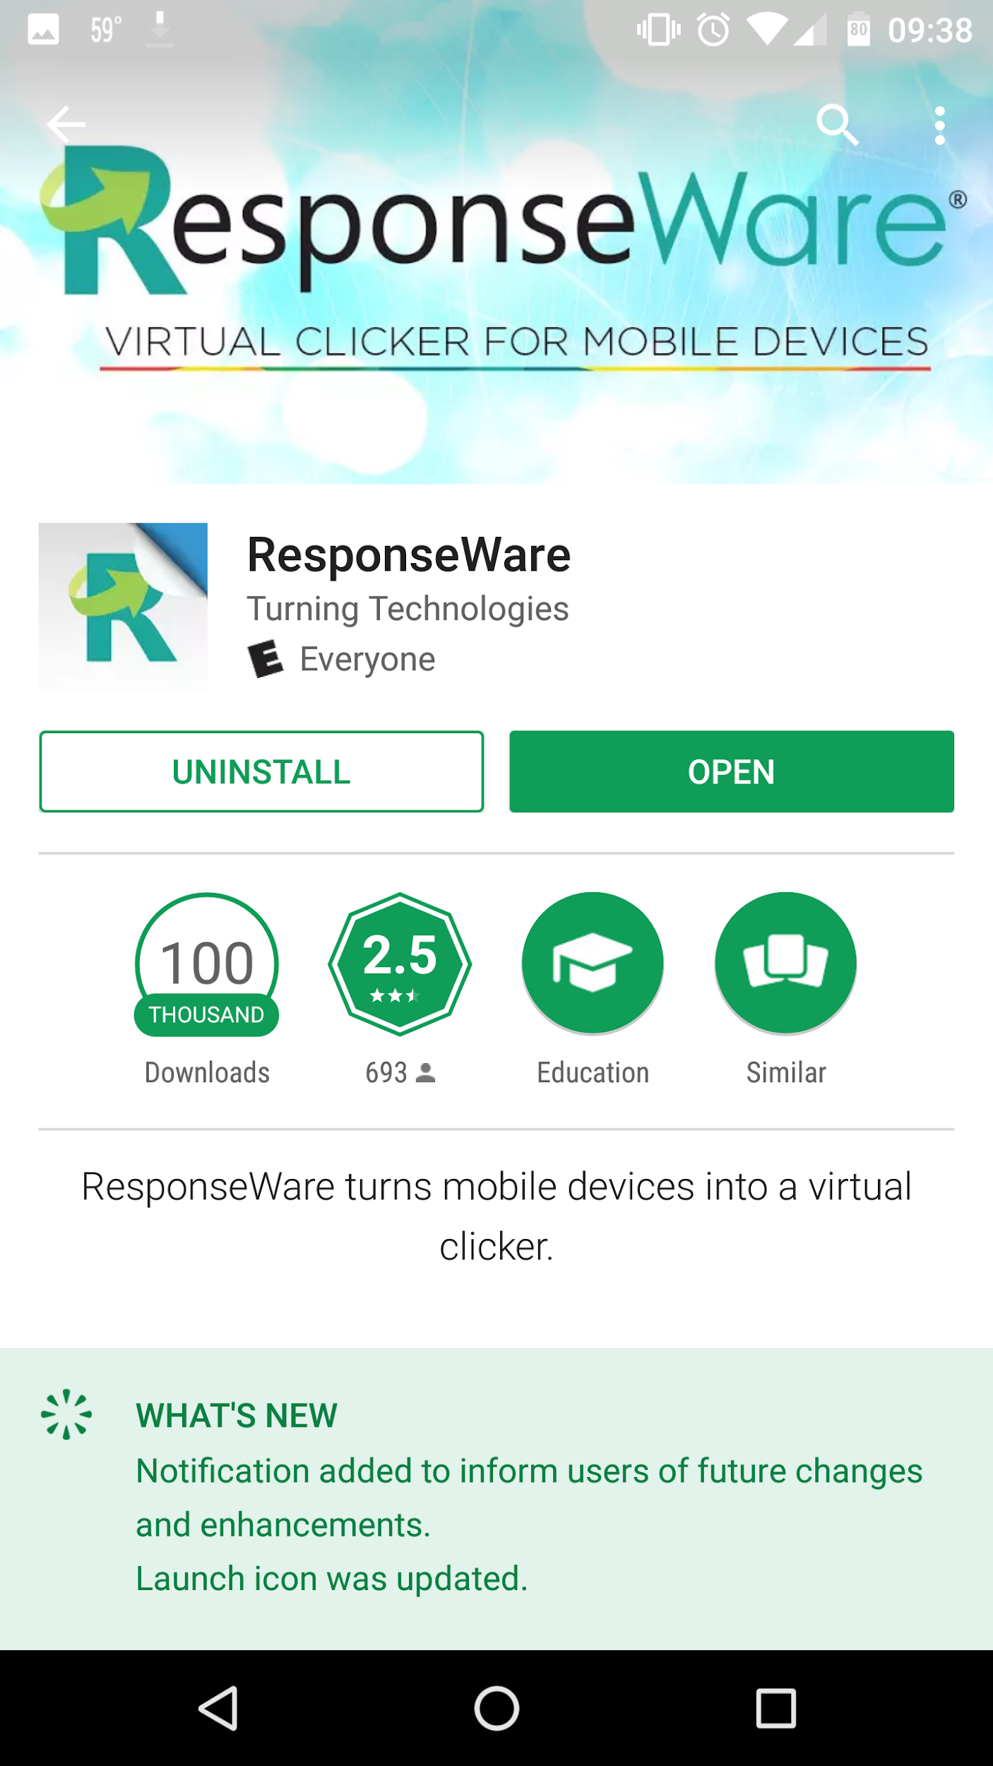

- Install and open app.
- You will now need to sign in.

For Apple
- Open Apple App Store.
- Search ResponseWare.
- Make sure it is created by Turning Technologies.
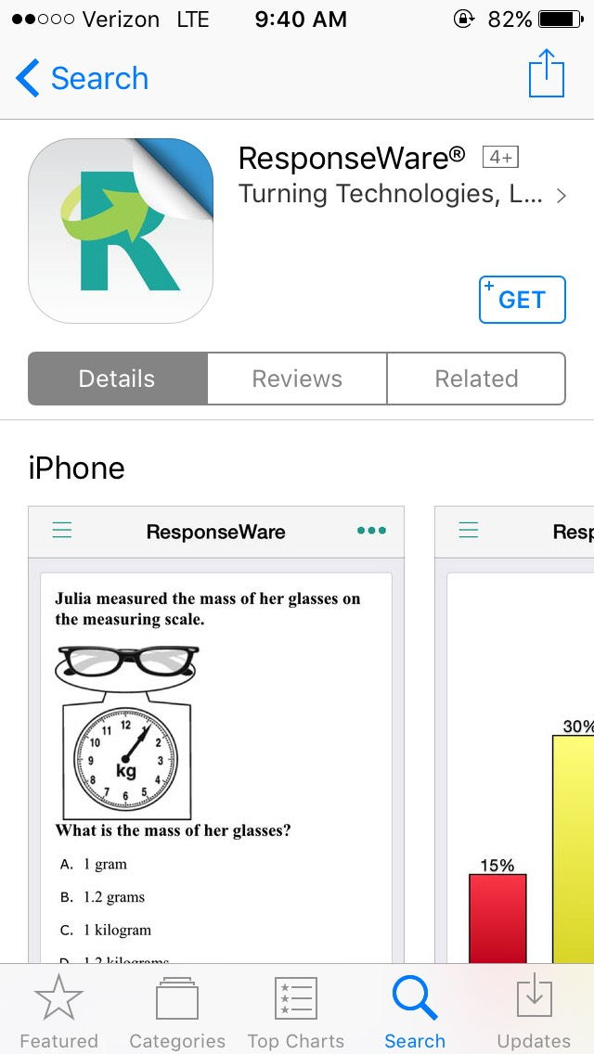

- Get app and open.
- You now will need to sign in.

After you have installed the app, you will need to sign into your account.
- Open ResponseWare on your device.
- Tap and select Sign In ( It should be in the top left corner of app.
- Enter your Uah Email.
- A Single Sign On page will pop up. Sign into your account with your Charger ID ( first of your email) and Password.
- You are ready to enter a session ID once it is given to you in class.

Accessing ResponseWare via the Web

- Go to https://responseware.turningtechnologies.com.
- Click Sign In (top right)
- Enter your UAH email.
- A Single Sign On page will pop up. Sign into your account with your Charger ID (first of your email) and password.
- You are ready to enter a Session ID once it is given to you in class.

