Fac
Microsoft Office User

Abstract
A guide to using the Faculty180 report system including screen shots of the UAH installation.
Version 1.0
Last Updated 10/15/2019
Faculty180
UAH Faculty General User Guide

Table of Contents
General Guidance 3
Required Data 3
Navigation 3
Editing 3
Attaching Files 3
Homepage 3
Action Items 3
Announcements & Help 4
Profile 5
Personal Information 5
Current Position 7
Interests 8
Degrees 9
Professional Licensures & Certifications 11
Academic, Government, Military and Professional Positions 11
Biography 13
Activities 14
Teaching 14
Courses Taught at Other Institutions 16
Teaching Innovations 17
Student Supervision 18
NonCredit Instruction Taught 19
Student Advising 20
Directed Student Learning: Counts 21
Directed Student Learning: Student Information 22
Scholarly Contributions and Creative Productions 23
Contracts & Grants 26
UAH Institutional Committees 27
UAH Other Institutional Service 28
Community Service 30
Professional Service 30
Other Service 31
Professional Development 32
Consulting 34
Honors 34
Memberships 35
Research In-Progress 36
Annual Goals 37
Fellows & Visiting Scholars Supported/Sponsored 38
Appendix I 39
Using Bibliographic data bases 39
A. Exporting Citations 39
1. Google Scholar 39
2. Scopus 39
3. EndNote and other Bibliographic Management Software 40
B. Importing Citations 40
Appendix II 42
Attaching Files 42
A. Course Attachments 42
B. Other Attachments 43

General Guidance

Required Data
Required elements are indicated by an asterisk (*) and must be completed before changes can be saved. Your college or department may require data for the completion of your Faculty Activity Report not required by Faculty180. Please refer to your college and department guidelines.

Navigation
Do NOT use the back arrow in your web browser while navigating between forms. Use the ‘Back’ button located at the bottom of each form to return to the previous form or select a form from the navigation menu to prevent a possible loss of changes.

Editing
All information in Faculty180 with the exception of the Teaching data may be edited at any time. You may save your data and return later to edit or update it. Only Evaluations are locked once submitted for review during the evaluation process.

Attaching Files
Many activity sections provide a mechanism to upload and attach files. Please see instructions in Appendix 2.

Homepage

The institutional homepage, navigation bar and ‘Action Items’ are displayed after logging in.

Action Items

Action Item section displays a list of outstanding tasks, such as completing an evaluation or accepting a co-authored work. Messages generated and sent to you by administrators also display here. Click on the item to view the details related to a task or message.
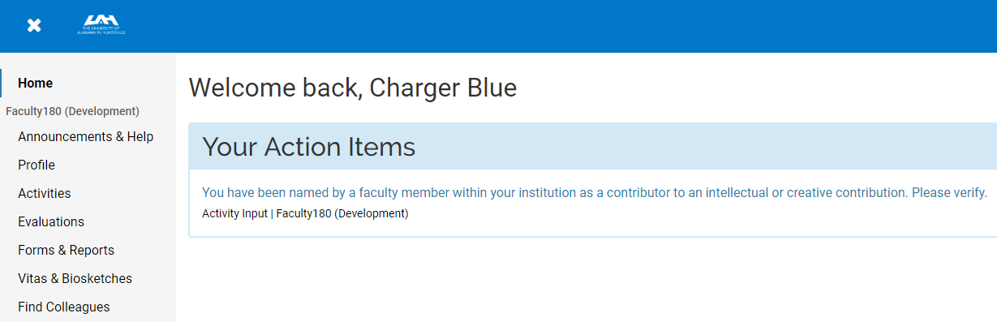

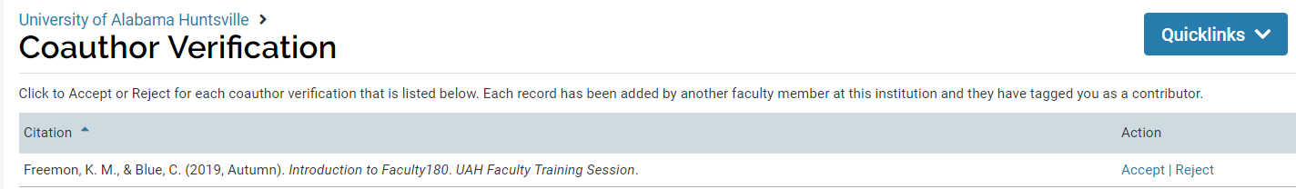

Announcements & Help

The Help link will redirect you to the Interfolio website with information and instructional videos regarding the basic functioning of the system. Please note that the software has been specifically configured for UAH and the sections and screenshots will differ from those displayed on the Interfolio website.
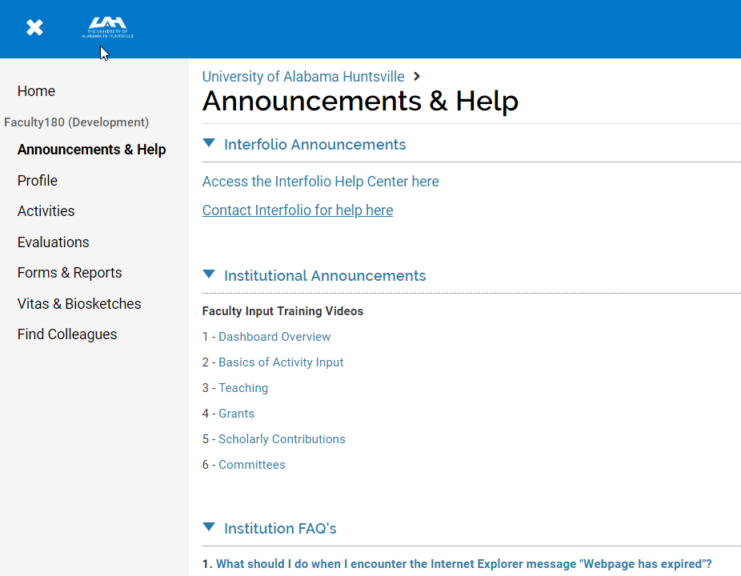

Profile

The profile section includes data that is for the most part static. Baseline data were was populated from Banner and may be updated directly through this form.
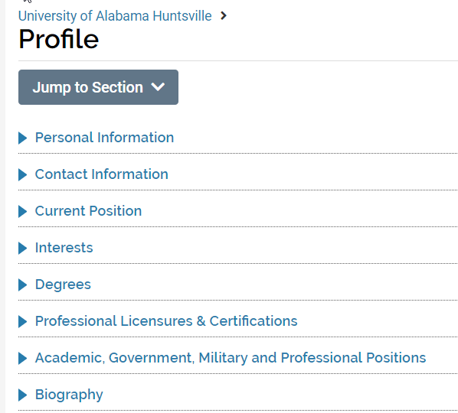

Personal Information

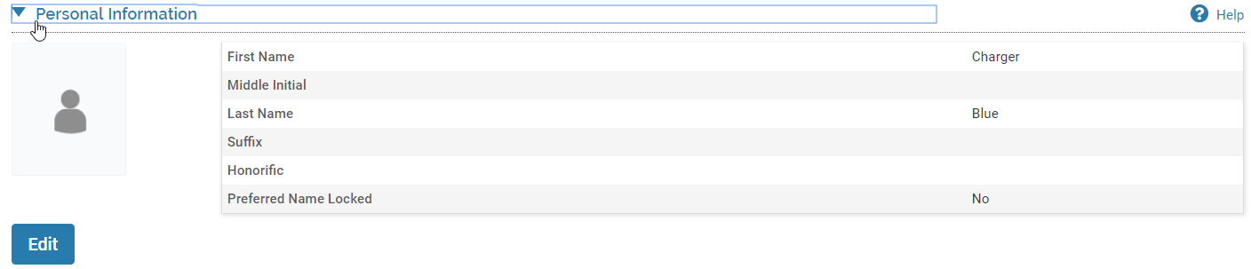
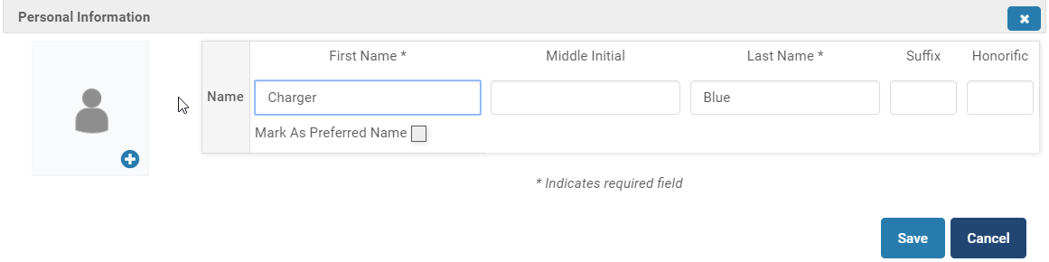
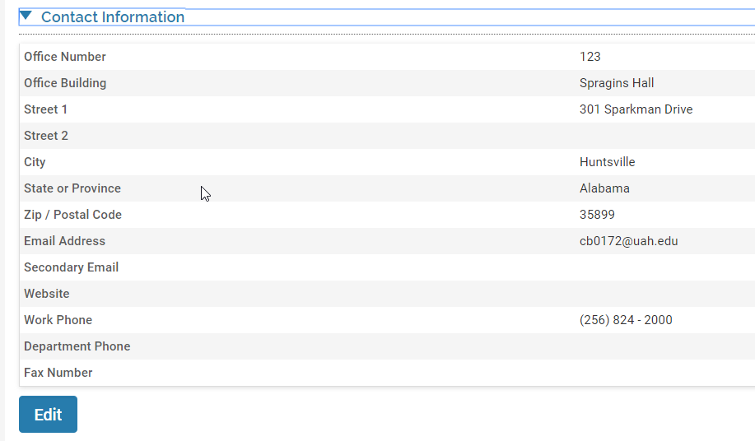

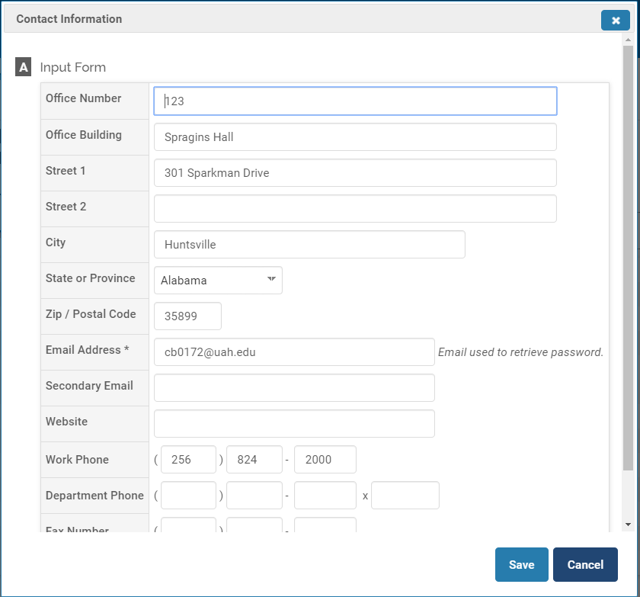

Current Position

Select your current academic rank from the drop down list of available options. Enter academic or administrative titles as free-form text if applicable.
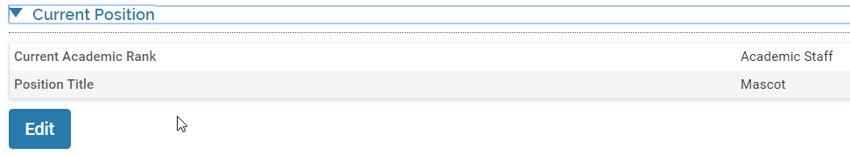

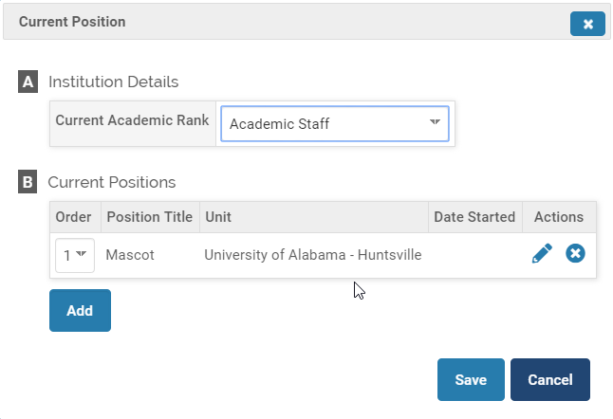

Interests

Record your specific teaching and research interests. If the ‘Find Colleagues’ functionality is enabled other faculty within the University will be able to search your interests and contact you for potential collaboration.
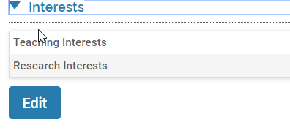

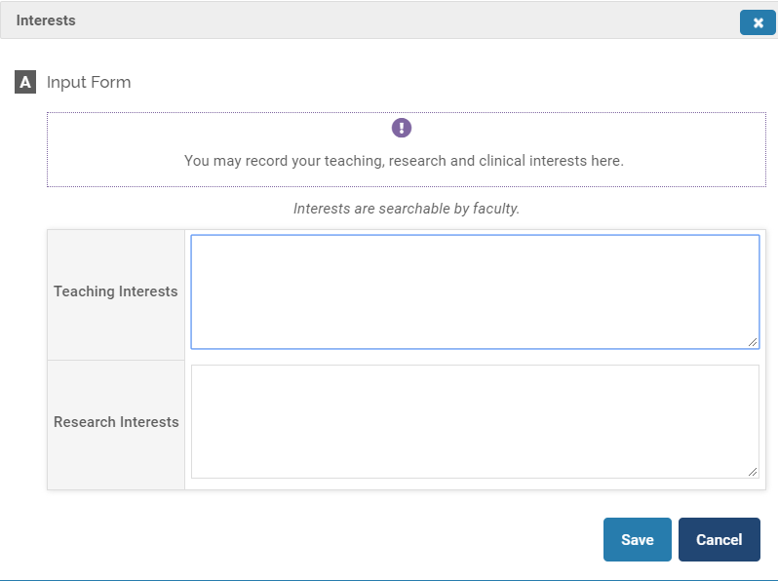

Degrees

Include all earned and in-progress degrees. Indicate the highest earned degree, year conferred and whether the degree is considered terminal in your field.
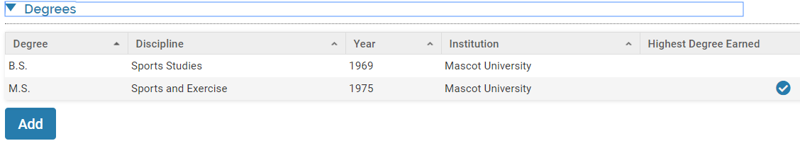
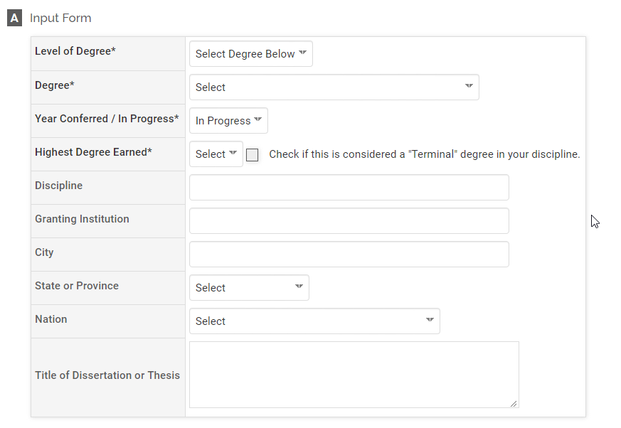
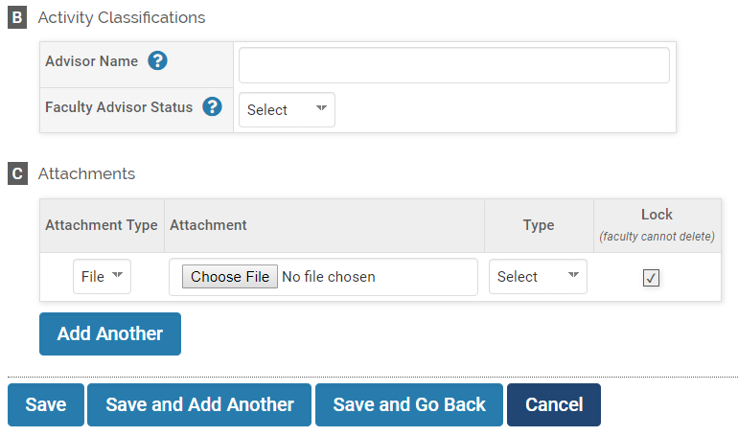

Professional Licensures & Certifications

Title and scope of professional licenses and certifications held. A copy may be attached.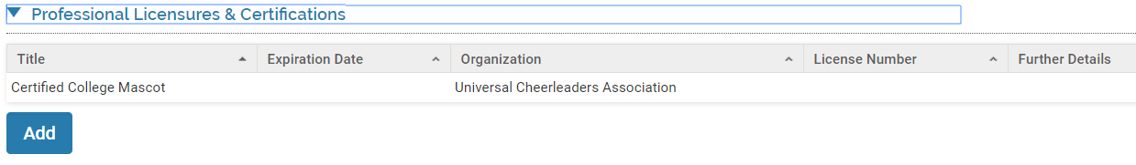
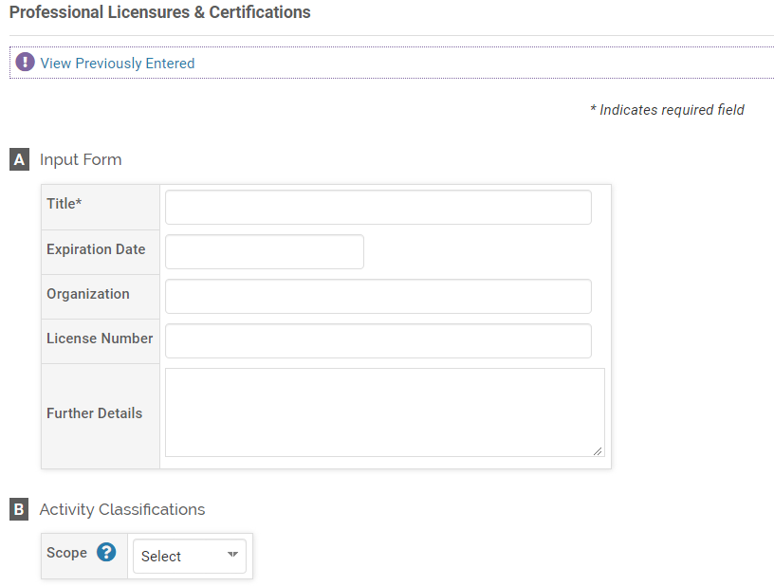
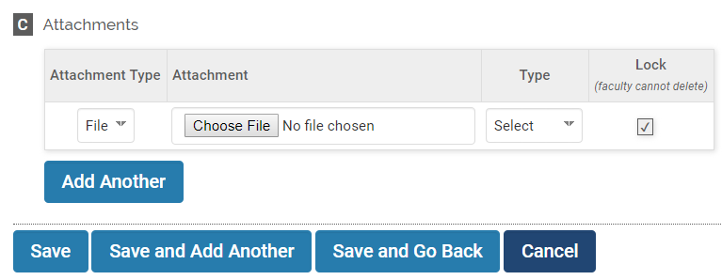

Academic, Government, Military and Professional Positions

Previous work experience. Identify the highest position attained, the organization and type/level of the institution or the employer. A text box is available to provide a description, responsibilities and additional information.
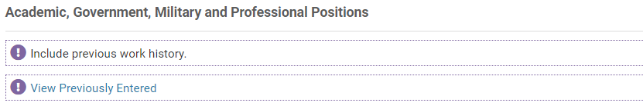
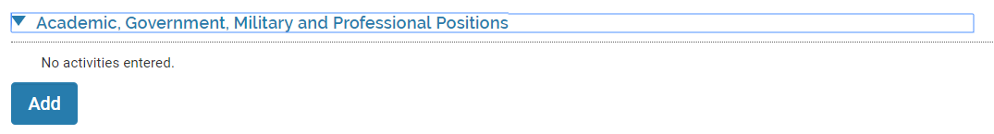
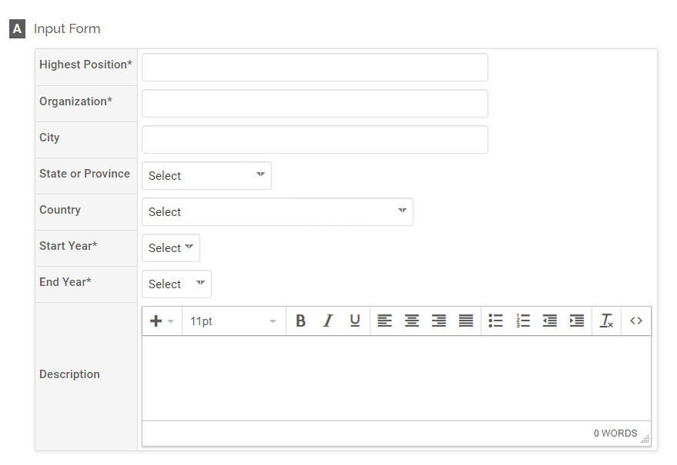
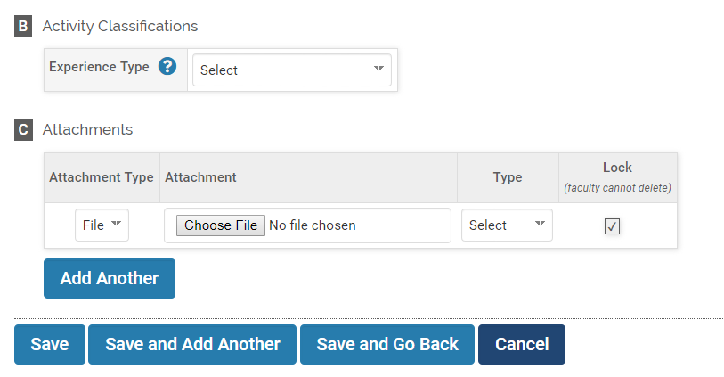

Biography

Personal or professional biography as free form text.

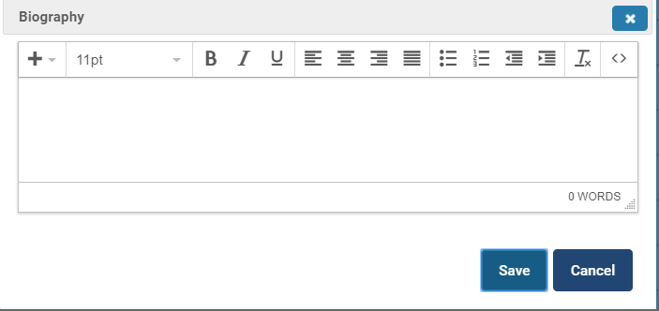

Activities

Professional and academic activities that will appear on the Faculty Activity Report and the corresponding Curriculum Vita. Activities are grouped into specific categories.
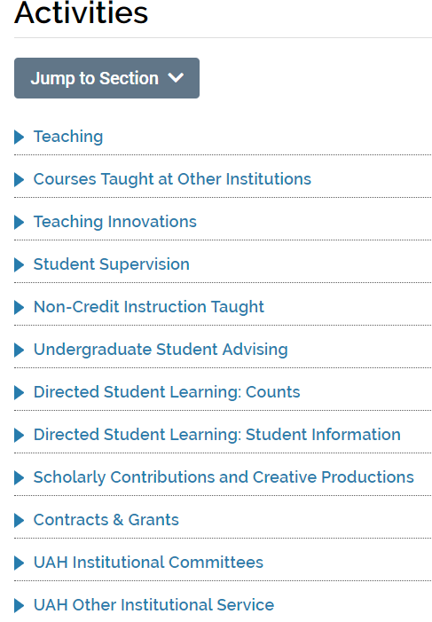
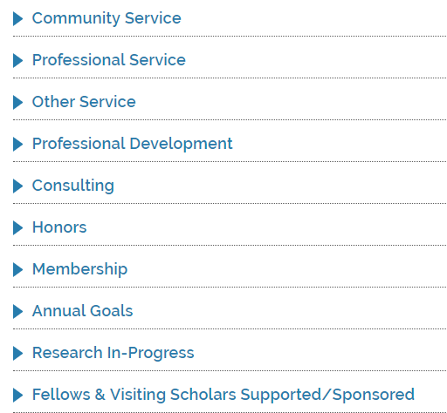

Teaching

Courses taught, enrollment information, grade distribution and Student/Instructor Evaluation scores and comments. The data will come directly from university systems of record and will not be editable. The approximate dates for data loads following the completion of the term are:
Fall | January 30th
Spring | May 30th
Summer | August 30th

SIE scores and grade distribution may be viewed by clicking the ‘View’ link under the ‘Additional Course Data’ heading. The SIE comments are attached to each course as a PDF file.
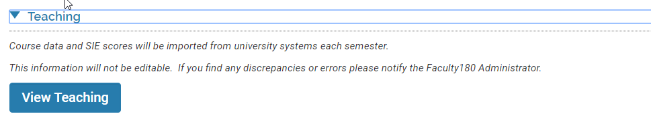
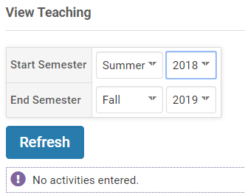
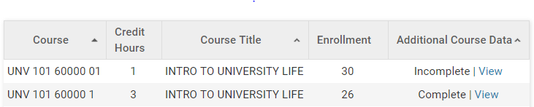
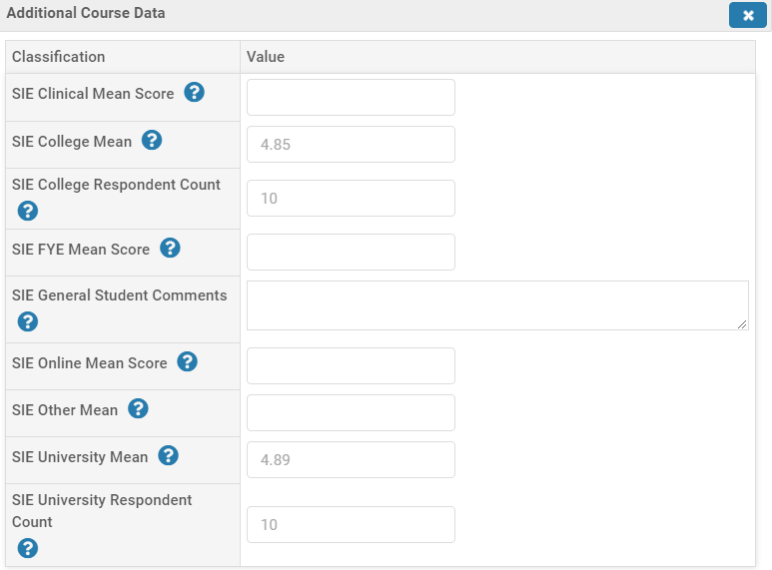
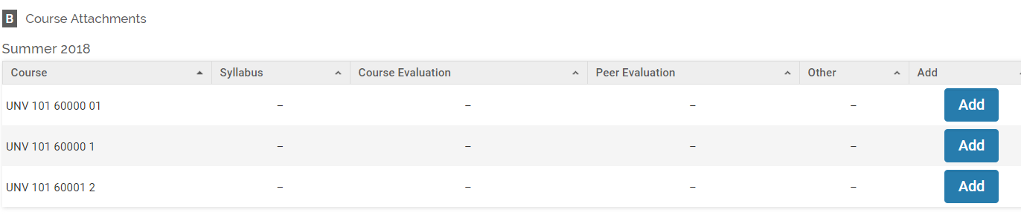

Courses Taught at Other Institutions

Teaching experience prior to UAH or as visiting faculty concurrent with your appointment at UAH.
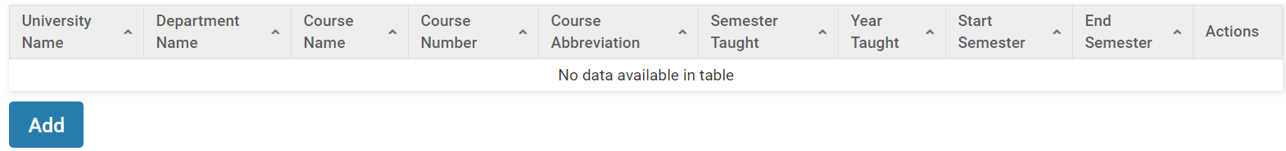
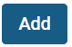
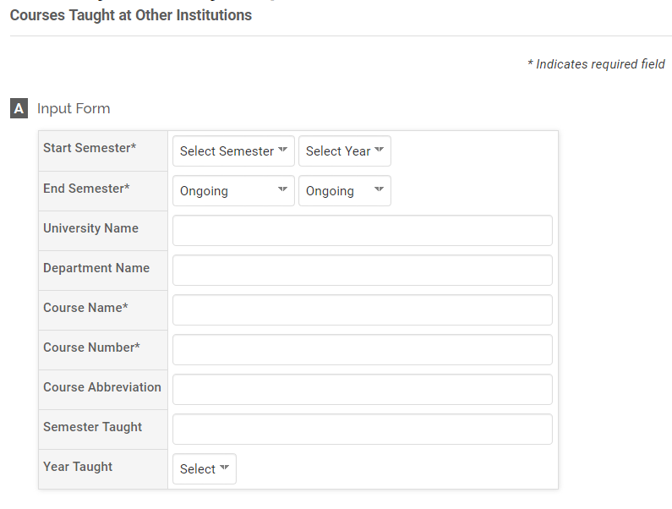

Teaching Innovations

New approaches, methods or materials used in your classes to enhance the student’s educational experience.
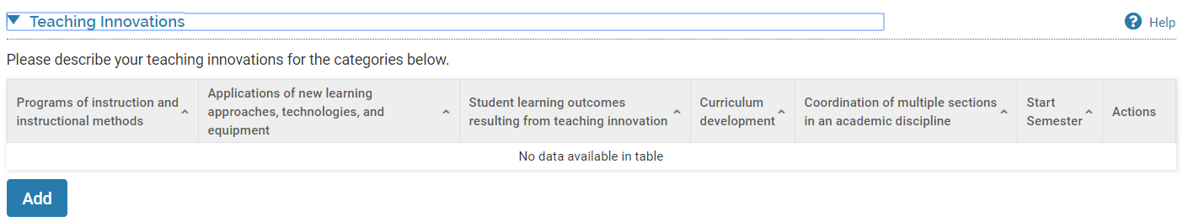
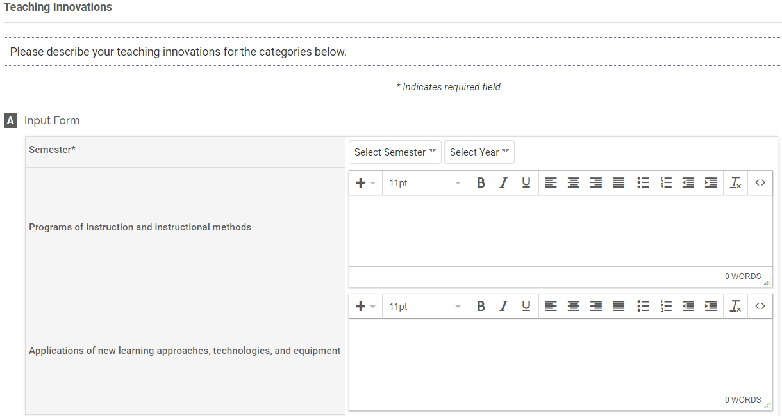
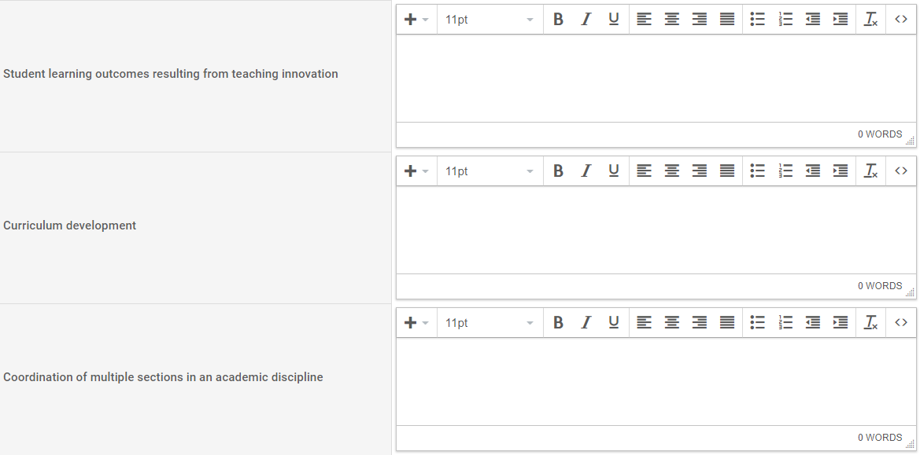

Student Supervision

Students supervised in a capacity outside of advising. Examples include student workers, lab assistants, etc. Note: Supervised research should be entered in ‘Directed Student Learning’.
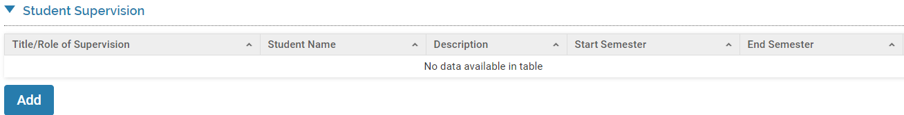
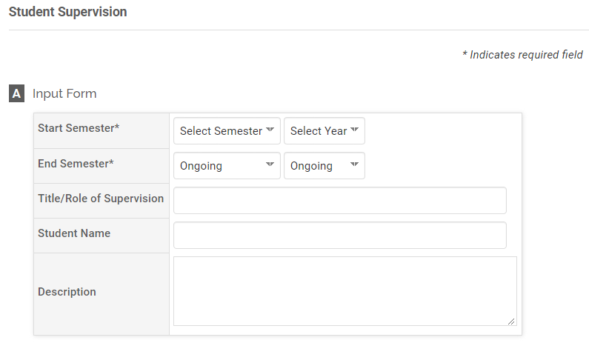

NonCredit Instruction Taught

Courses conducted with zero credit hours or continuing education units.
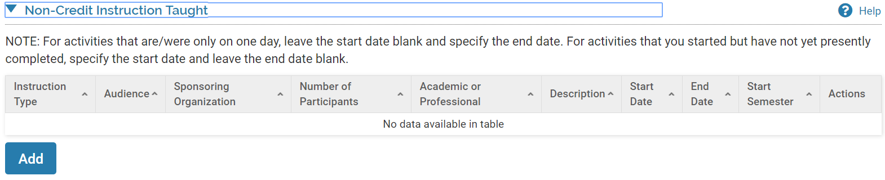
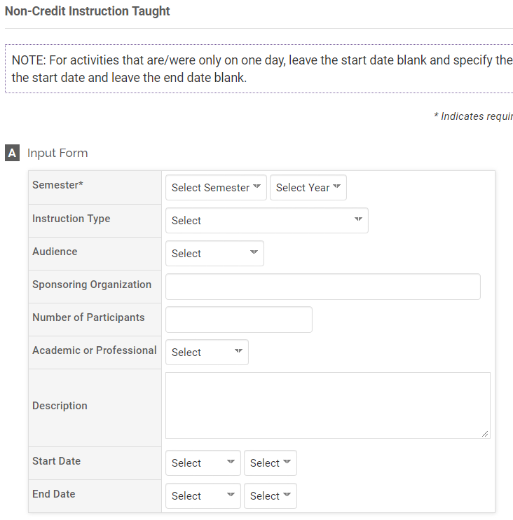

Student Advising

Students for whom you provided formal advising regarding their educational plan, program or class schedule.
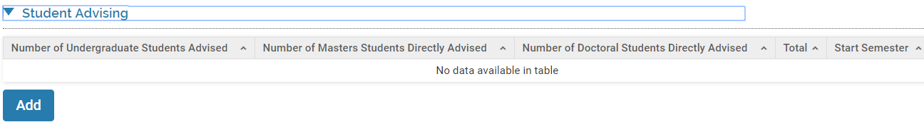

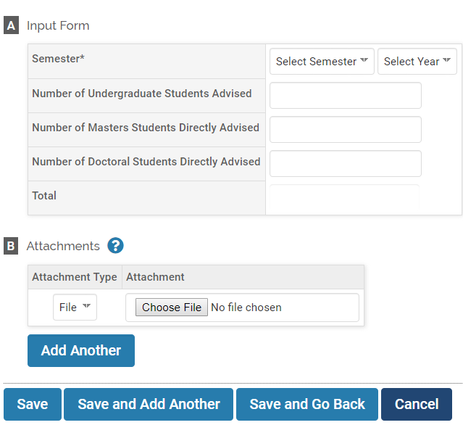

Directed Student Learning: Counts

Aggregate information regarding students for whom you acted as an advisor, co-advisor, or committee member for a thesis or dissertation
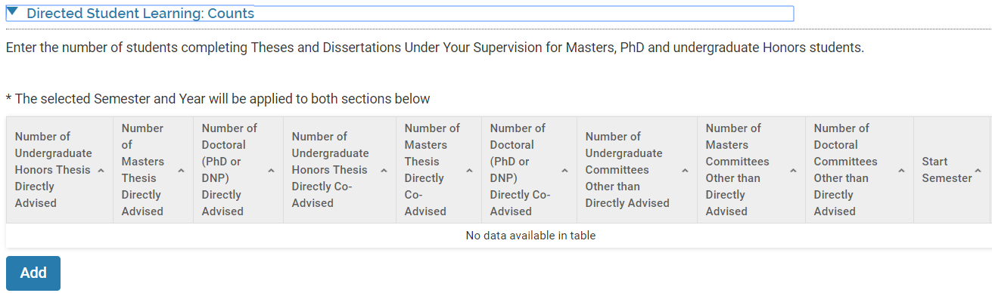

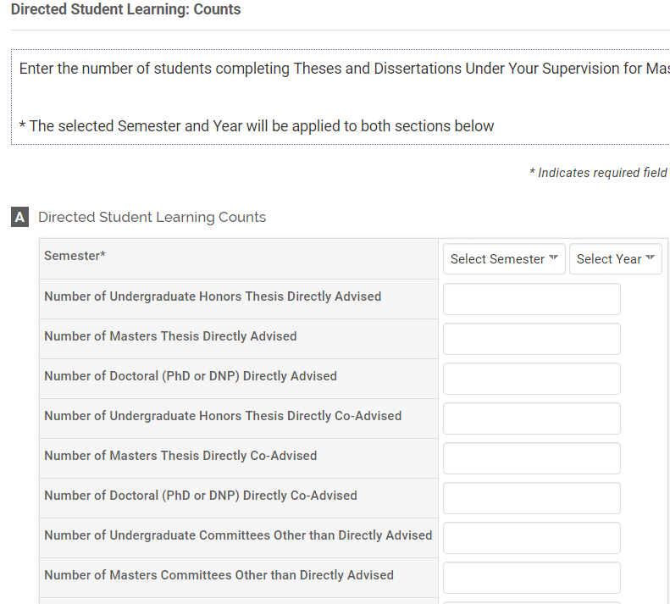

Directed Student Learning: Student Information

Students who are performing research under your supervision.
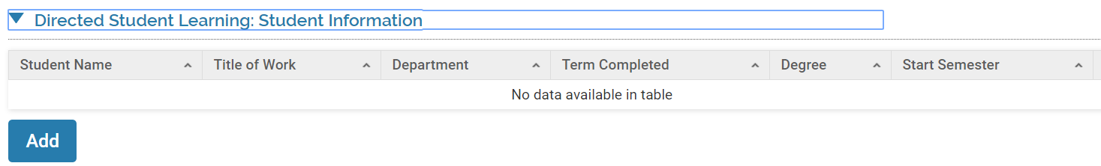

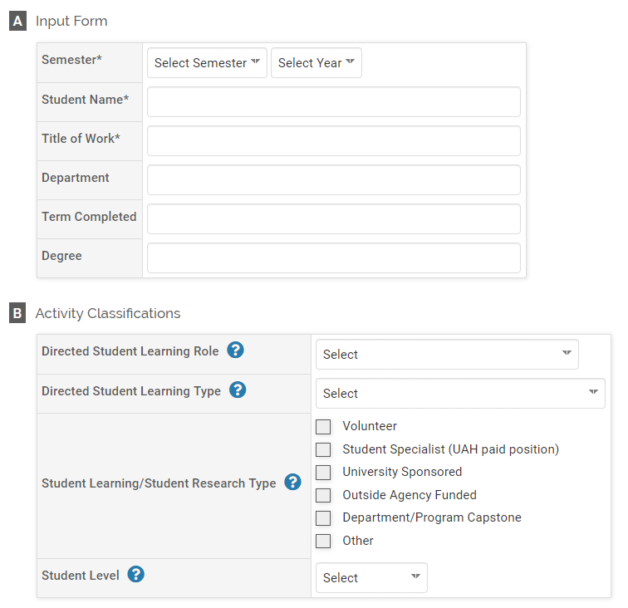

Scholarly Contributions and Creative Productions

Details of your publications, presentations and creative works. Citations may be directly imported from bibliographic databases and reference management software like Google Scholar, EndNotes as well as others. For instructions on importing please refer to Appendix I.
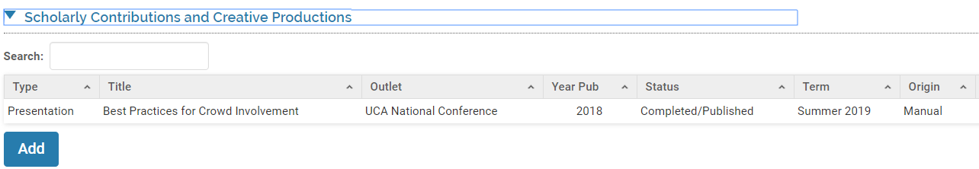
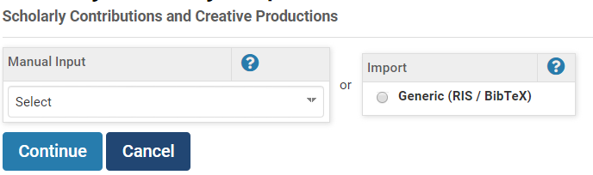
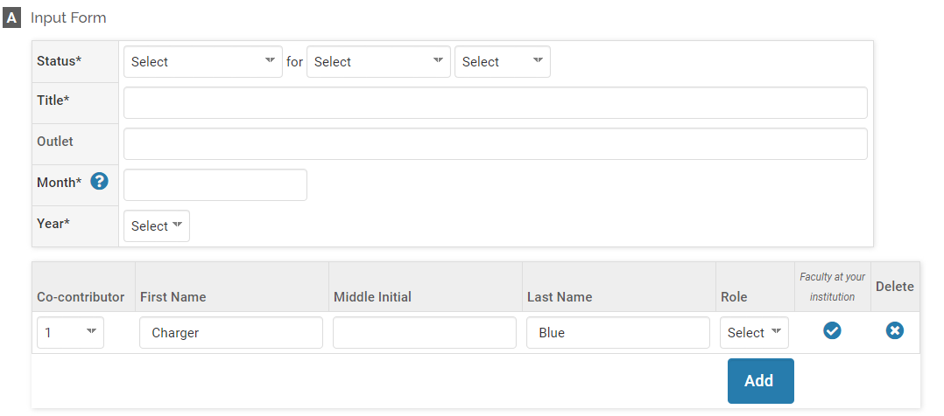
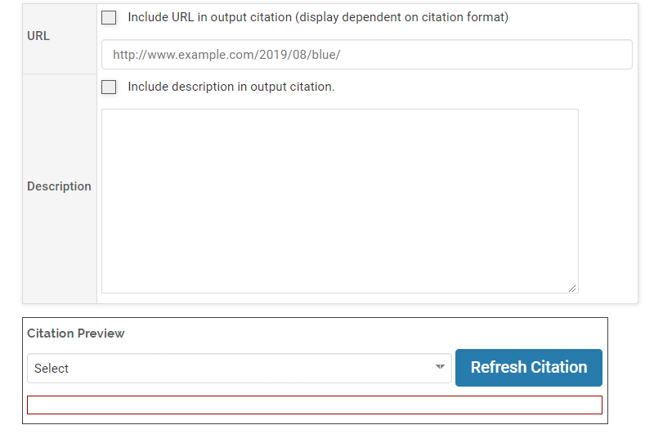
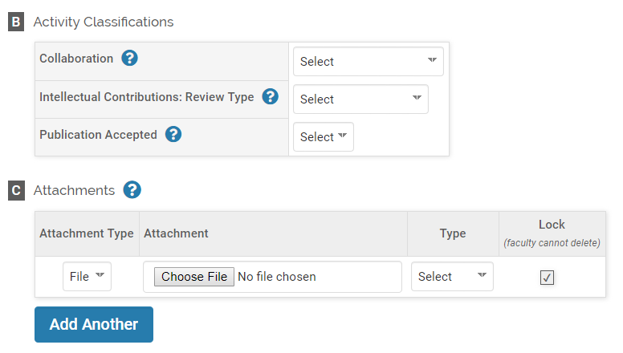

Contracts & Grants

Sponsored research, grants and contracts.
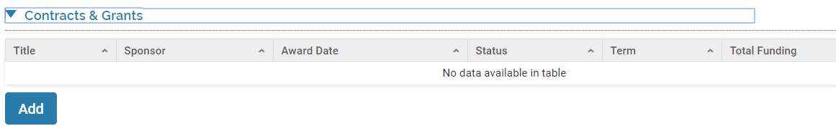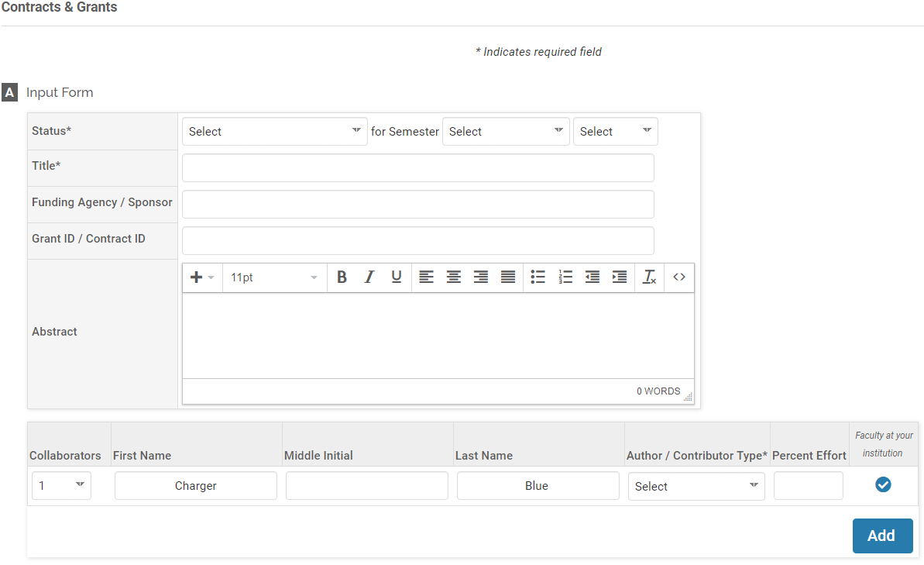
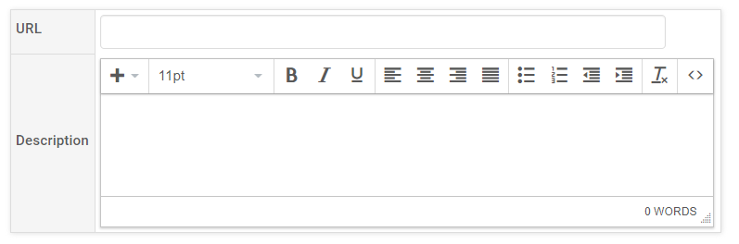

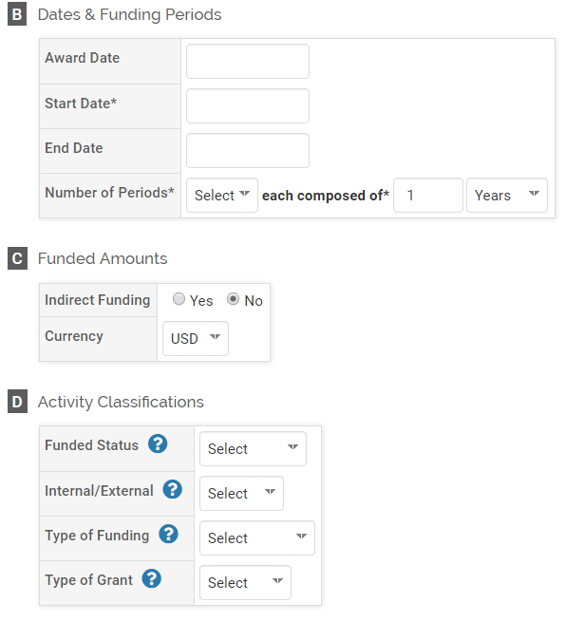

UAH Institutional Committees

Participation on committees in service to your department, program, college or the university.
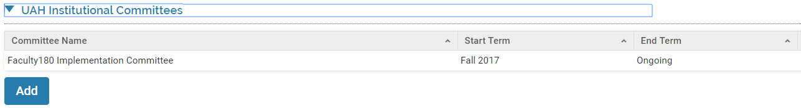

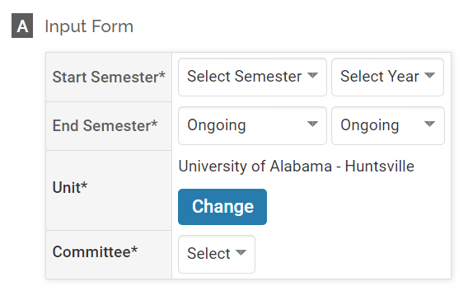
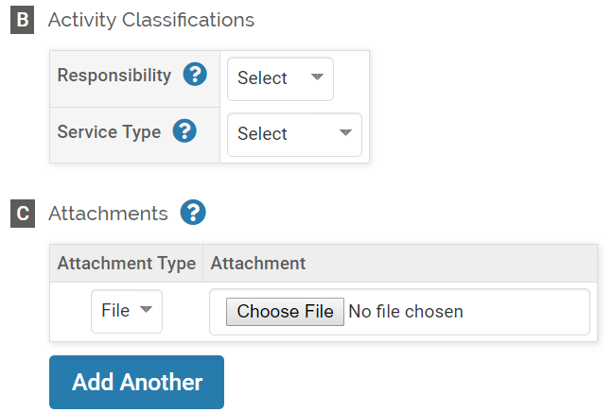

UAH Other Institutional Service

All other service to the university that falls outside of a formal committee. Examples include sponsoring or organizing a campus event, acting as an advisor to a student organization, participating in a college fair or discovery day. Identify the activity by the following categories: Recruitment, Retention, Accreditation or Program Evaluation.
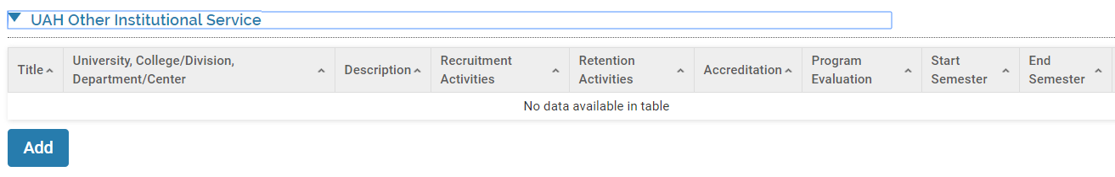
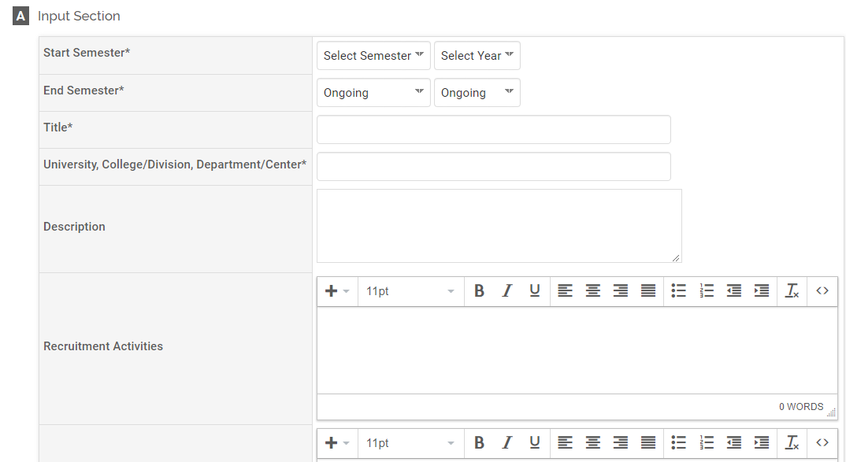
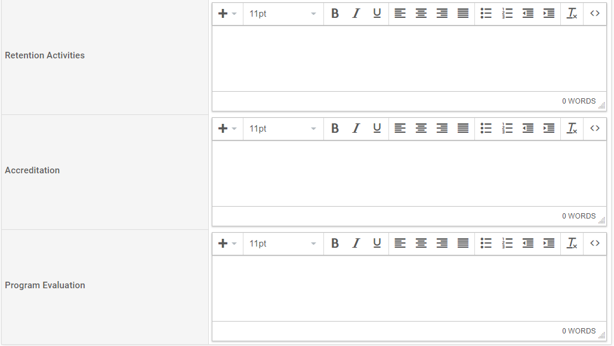
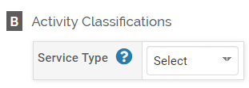

Community Service

Service performed outside the university. Examples include sponsoring or organizing a community event, volunteering with a civic organization, faith-based organization or nonprofit group.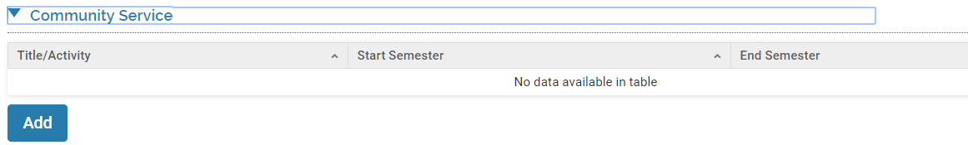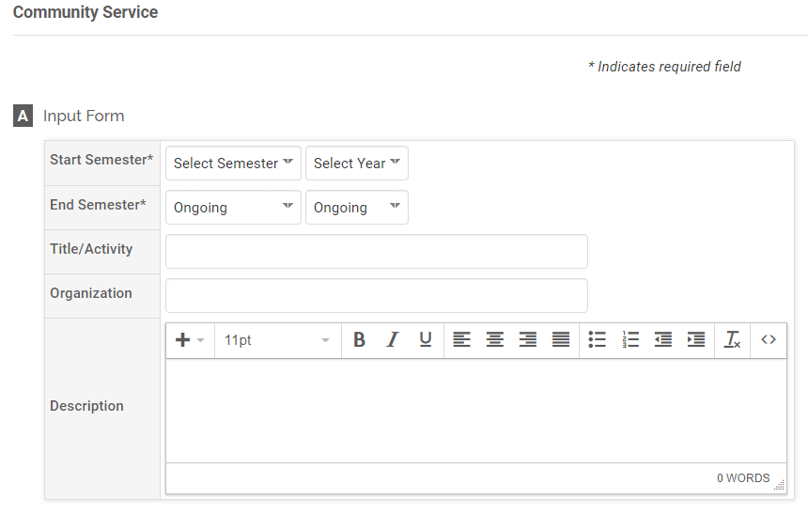
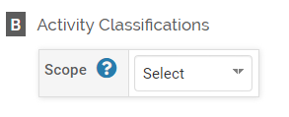

Professional Service

Service provided on behalf of your academic profession. Examples include serving in a leadership role, sponsoring or organizing an event or providing support to a professional society or organization.
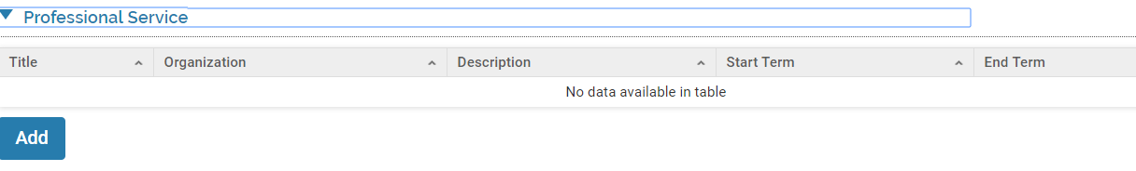
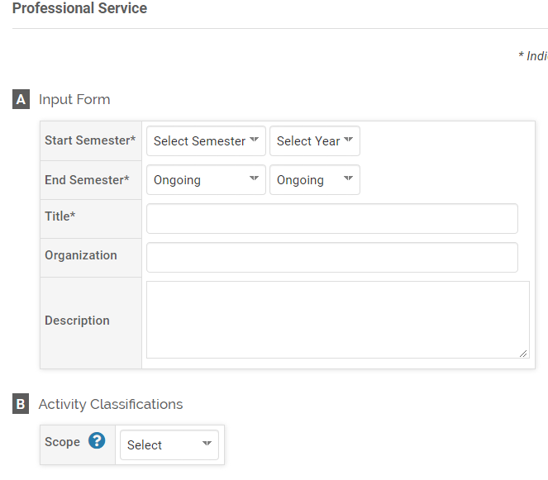

Other Service

Service that does not fall within the preceding categories.
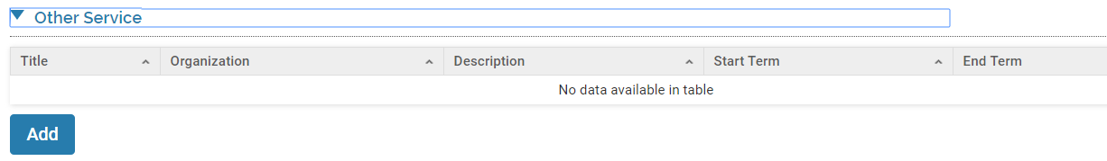
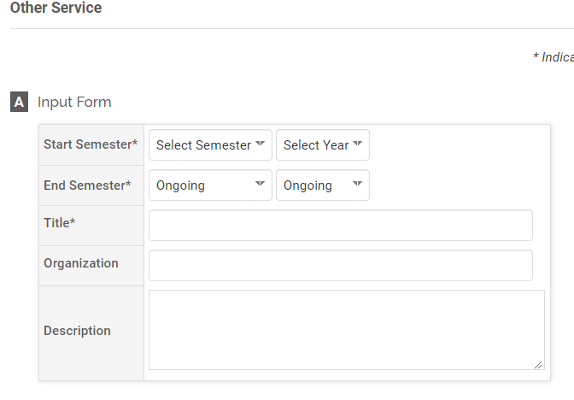

Professional Development

Any continuing education courses, programs, seminars, conferences, workshops or other learning opportunities attended to further your professional knowledge.
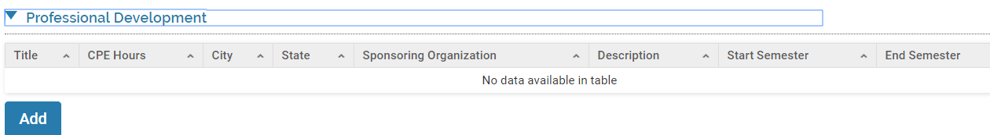

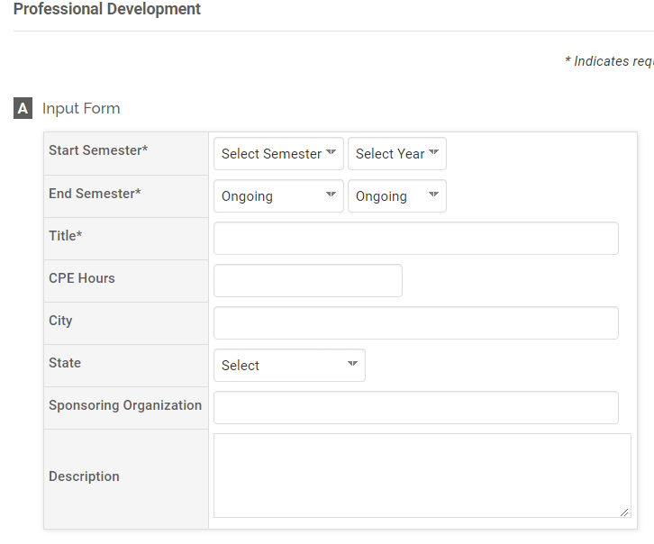
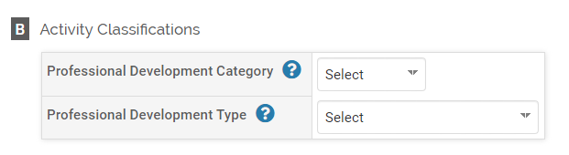

Consulting

Paid or unpaid consulting services provided to an entity outside the university.
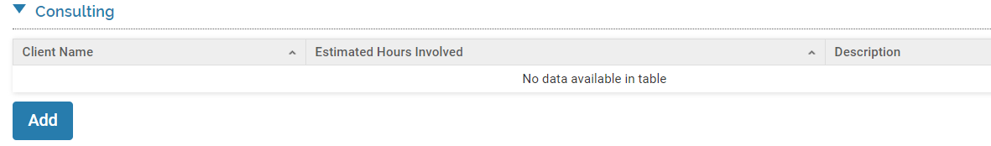
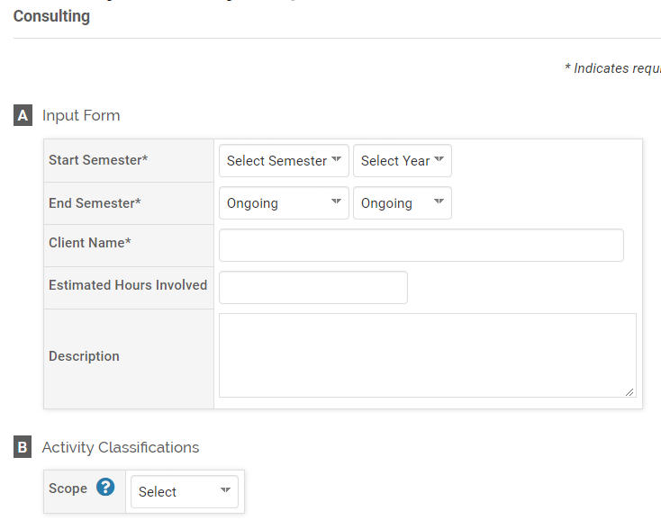

Honors

Honors or recognition received for professional or personal achievement.
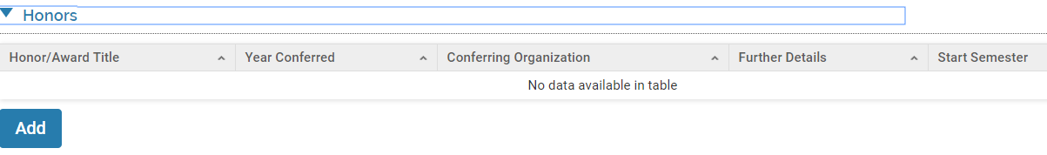
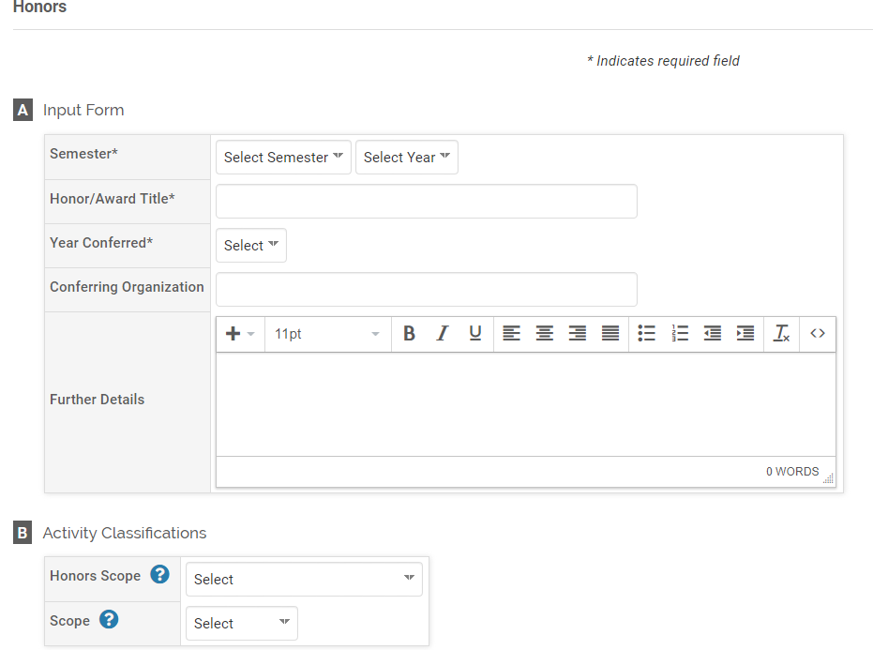

Memberships

Organizational or societal memberships held.
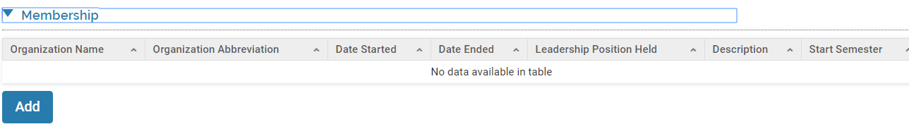

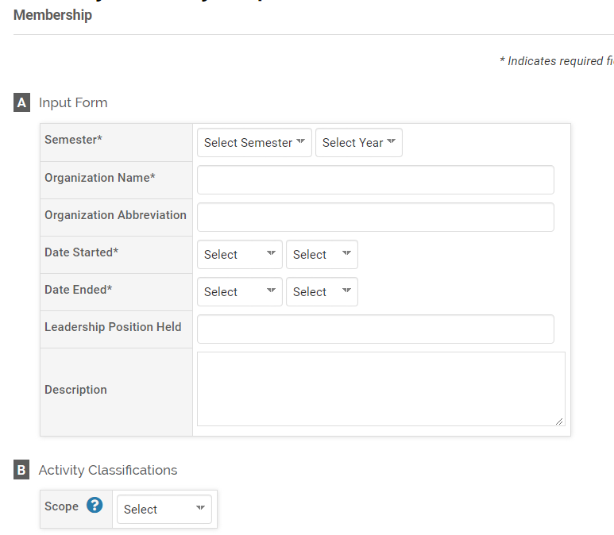

Research In-Progress

Research studies or projects currently underway.
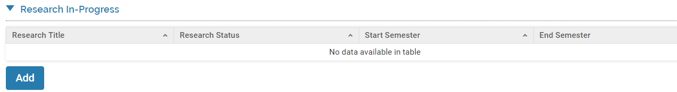
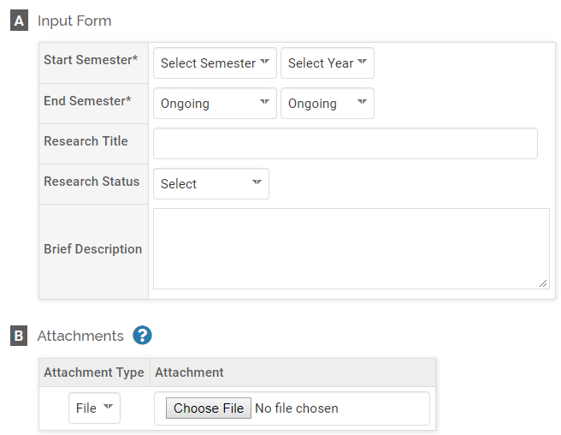

Annual Goals

Your personal goals for teaching, research and service.
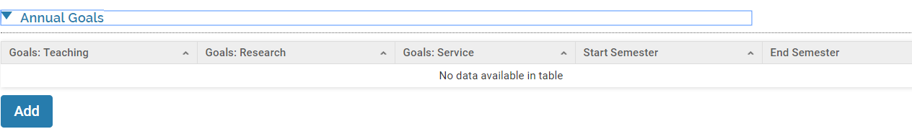
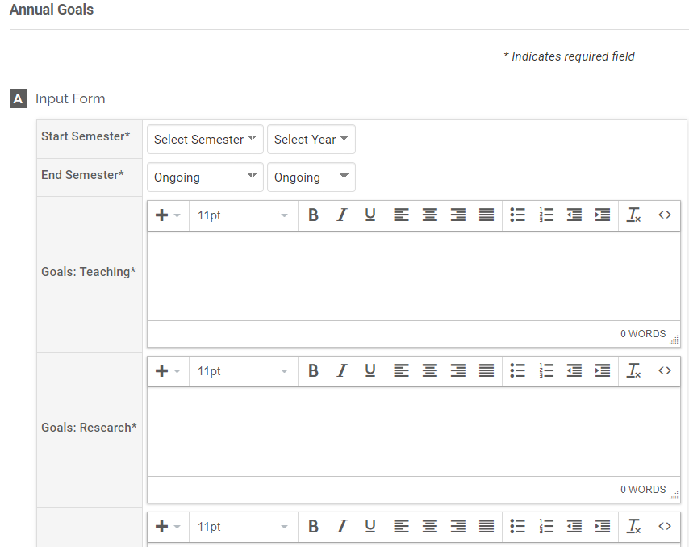
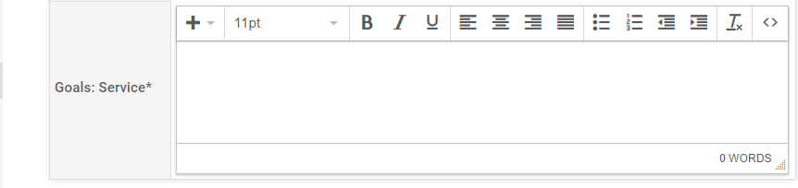

Fellows & Visiting Scholars Supported/Sponsored

Identify fellows or visiting scholars to UAH whom you sponsored or provided financial support.
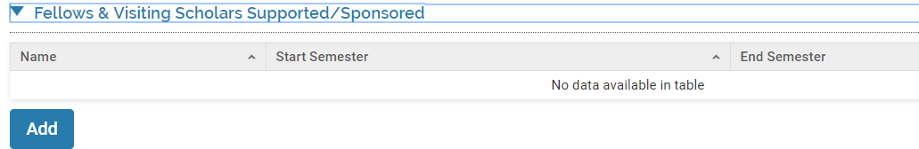
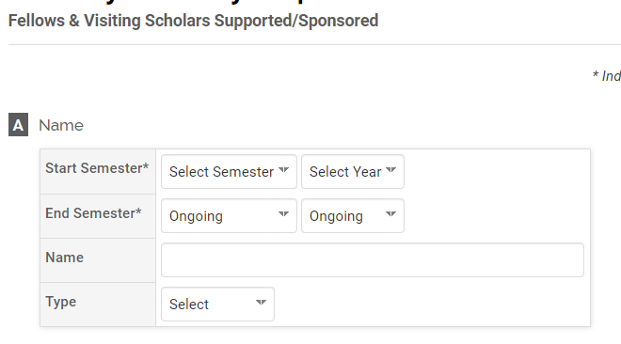

Appendix I

Using Bibliographic data bases

Exporting Citations

Citations can be imported into FACULTY180 in RIS or BibTeX format or copied and pasted individually. Both methods are described below.

Google Scholar

Exporting from Google Scholar/Import into Faculty180 via a BibTeX file:

- Log in to Google Scholar. On the My Library screen, select all of the relevant citations that you would like to export by clicking the box next to ‘Title’.
- Select the export icon.
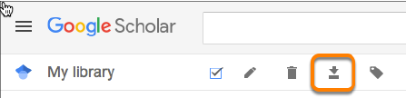
- Choose the BibTex format.
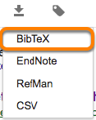
- Save as the file to your computer with a .bib extension.

Scopus

This works best if you access Scopus through the Rasmuson Library.
1. On the Rasmuson home page, select the Databases by Title link in the center of the Quick
Search field.
2. Locate Scopus from the list of available titles.
3. Click the tab for “Authors.” Search using your name and institutional affiliation. Use the advanced search to include more details.
4. Click the box next to your listing, and “show documents.”
5. Select the documents you wish to upload. Click “Export.”
6. In the pop-up box, click RIS or BibTex and the “Export” button.
7. Save the file. Your pubs will be in your downloads folder and will have a name like “scopus.ris.”
8. Either import as a .ris or .bib file, or open the file and copy/paste the contents into Faculty 180.

3. EndNote and other Bibliographic Management Software

- Select Export from the File menu.
- Export as BibTeX Output Style.
- Save the file to your computer.
- Import using the directions

Importing Citations

- Log in to your Faculty180 account.
- Select the Activities form.
- Open the Scholarly Contributions and Creative Productions section and click the expand icon to expand the section.
- Click the Add button.
- Click the Generic (RIS / BibTeX) import option.

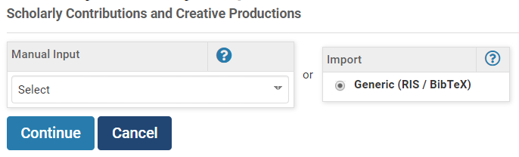
- Click the Continue button.
- Select BibTeX as the citation format.

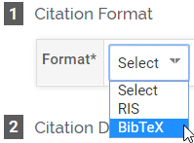

- Click Choose File as the import option in the Citation Data section and browse to the location of the saved citation. Select the citation file.
- Click Save.

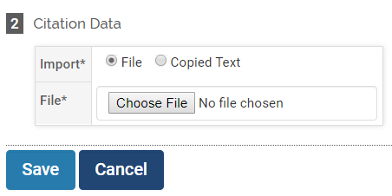

Note: Select the citations to import. Use the check box in the heading row to select or unselect all citations.
- Click Import Selected.

Appendix II

Attaching Files
- Course Attachments
Navigate to the Teaching activity section. Click the ‘View Teaching’ button. Select the appropriate time range and click ‘Refresh’ to display courses.

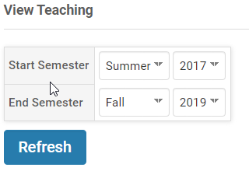
Scroll down to section C for Course Attachments. Select the ‘Add’ button to the right of the desired course.
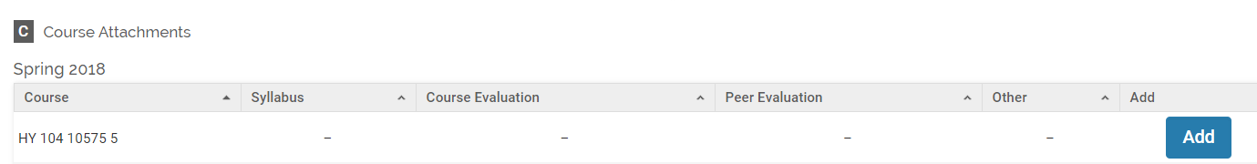
Select the Attachment Type (File or URL). Click the ‘Choose File’ button and locate the desired file on your computer. Select the File Type.
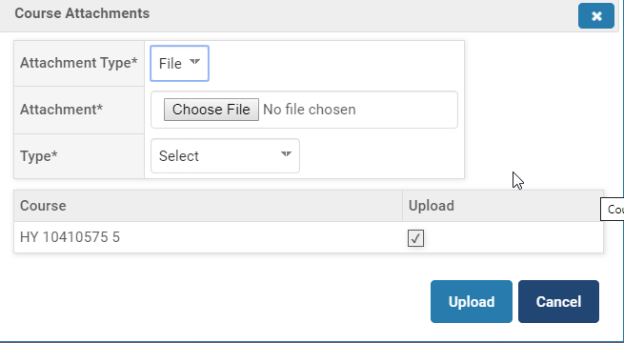
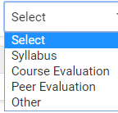
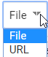
- Other Attachments
To attach files to activities in other sections scroll down to Section C. Click the ‘Choose File’ and locate the desired file on your computer. Select the ‘Attachment Type’. Select the ‘Type’.

