Navigation in SAP Systems
Introduction to Navigation in SAP solutions on the basis of SAP S/4HANA
Student Name:
User ID:

Product  S/4HANA 1709  Global Bike  GUI 7.50  Level  Beginner  Focus  Navigation  Authors  Babett Ruß  Stefan Weidner  Version  3.3  Last Update  May 2019 | MOTIVATION  This material explains how to navigate in SAP systems. It is aimed at students at universities, universities of applied sciences and other educational institutions with no previous experience of SAP software. It can be used in the class or for self-study.  After completion of the course, students will be able to navigate through the user interface to work on business processes and case studies on their own.  Furthermore, this material serves as a reference for occasional users of SAP systems. |  | LEARNING METHOD  The learning method used is guided learning. This is a suitable method because navigating in SAP systems is a fundamental skill but also very complex.  The benefit of this method is that knowledge is imparted quickly. Students also acquire practical skills and competencies. Similar to a case study, this method explains a process or procedure in detail.  By using exercises at the end of each part, students can put their knowledge into practice and gain a sustainable understanding of the underlying processes.

 | Step 1: Logging On
Task Log on to the system.  Short Description Use the SAP GUI to log on to the SAP system. |  | Time 10 Min.
Always work with your data. You have access to other student’s materials and if you do not use your own identifier, you affect another student’s work.
Be cautious about other classmates attempting to use your identifier, intentionally or unintentionally. If you suspect something is amiss, contact the instructor immediately.

Find and double-click on the icon depicted on the left side of this page that you can find on your desktop. If it is not there, choose Start ► All Programs ► SAP Front End ► SAP Logon  A dialog box similar to the one shown below appears. Select the SAP system specified by your lecturer and choose Log on or Enter. |  | SAP Logon
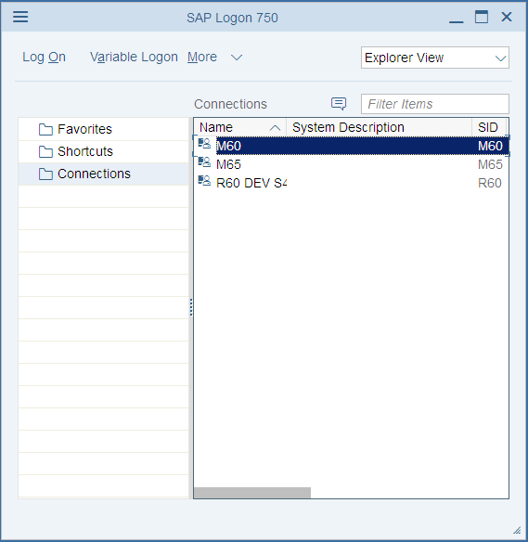
The logon screen appears. The system requests the client, your user, password, and preferred language.
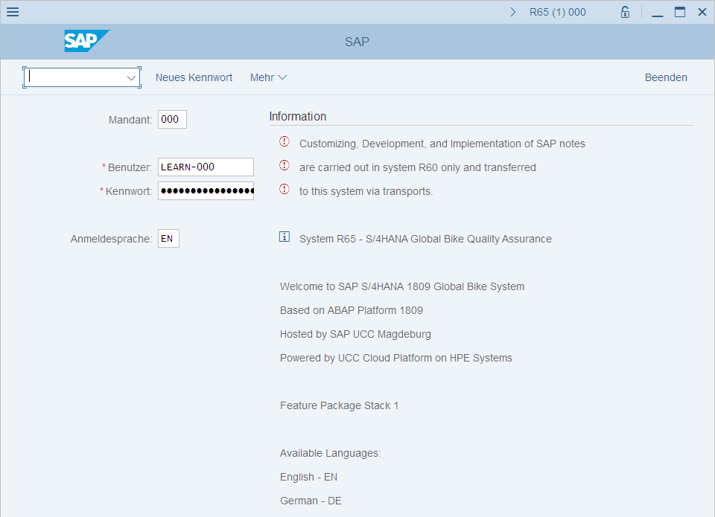 |  | Client: _ _ _  User: _ _ _ _ _ _ _  Password: _ _ _ _ _ _ _  Logon Language: _ _
Before you log on, you need to know the definition of the term “client.”
SAP systems are client systems. With the client concept several separate companies can be managed in one system at the same time.  Clients are the highest organizational level in the system. In business terms, each client can represent a group of companies, a company, or a firm – regardless of the size of the organization.  In commercial, organizational and technical terms, a client is therefore a self-contained unit with separate master records and its own set of tables. In SAP systems, different clients are identified by their client numbers. |  | Client
Use the client number given by your instructor. For you to be able to log on as a user, a user master record must be created for you in the relevant client. For reasons of access protection, you must enter a password when you log on. Your password entry is case-sensitive.  SAP systems are multilingual. Choose the language for your session in the Language field. Then choose Enter. |  | Logon screen
Enter the user name, the initial password and the logon language given by your lecturer.
When you log on for the first time, a dialog box appears in which you enter your new individual password twice.
Client: _ _ _
User: LEARN-###
Password: tlestart log on
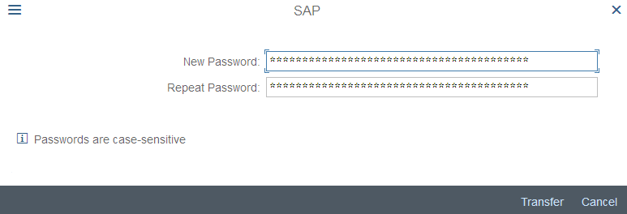
The first time you log on you will see a copyright note. Confirm it with or Enter.
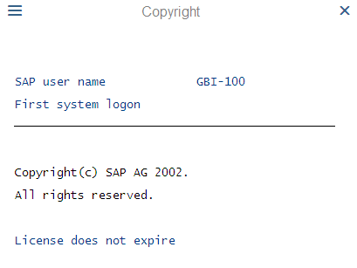
The initial screen with the SAP Easy Access Menu appears.

 | Step 2: Initial Screen
Task Get familiar with the SAP system screen.  Short Description Identify and familiarize with each element of the SAP system screen. |  | Time 10 Min.
This is the initial screen as described in more detail below.
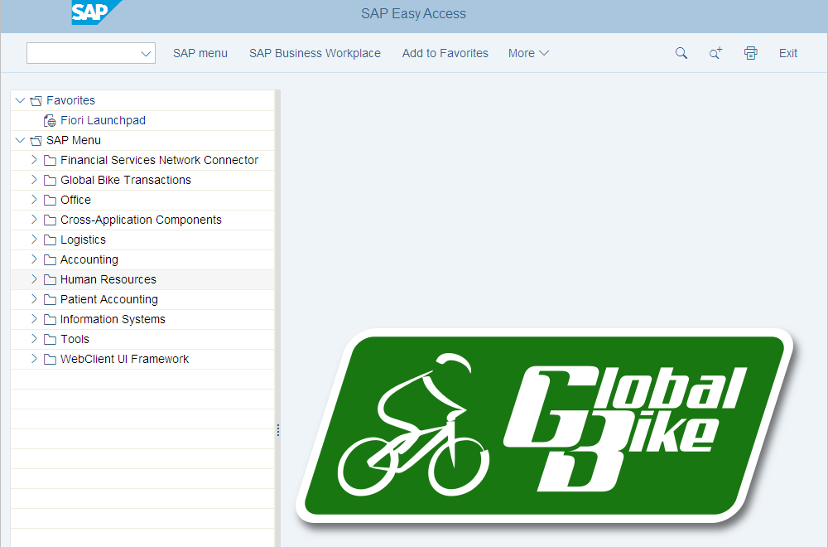 |  | Initial screen
Menu Bar |  | Menu Bar
The displayed menus depend on the action/transaction in the SAP system except for the system and help menu. This dependency is described as context sensitive.
Title Bar |  | Title Bar
The title bar displays the name of the transaction you are currently using. It is located on every primary window and dialog window under the standard toolbar and above the application toolbar.
Application Toolbar |  | Application Toolbar
The application toolbar contains icons and buttons applicable to the transaction you are currently using. Example: Transaction SU01 User Maintenance: Initial Screen.
SAP Easy Access Menu  The SAP system displays the SAP Easy Access menu on the start screen as standard. It enables you to navigate in the system using a clear tree structure.  Click on the small arrows to expand the menu tree. The menu tree is specific to your role (business function in the company). |  | SAP Easy Access Menu
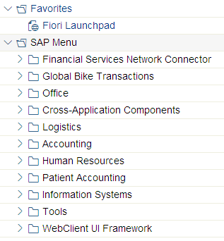
Exercise
Open the following tree structure!
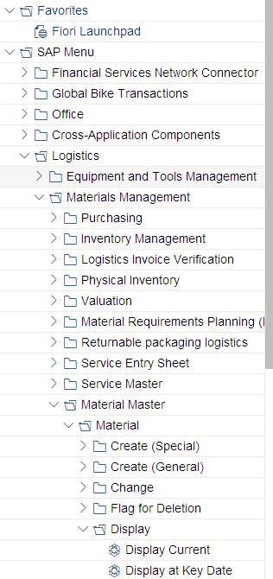
Exercise 1 (Type your answers here)
  - What is the difference between the transactions Display Current and Display at Key Date?
    - In the Application Menu Bar click on the SAP Menu Button or . What does it do?

Status Bar |  | Status Bar
The status bar shows information over the actual system status. You find it in the upper corner of your screen.
Click on the actual system.
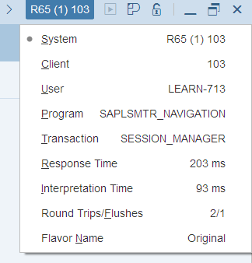
There you find information about your client, user and also the current transaction.
Follow the menu path:
Logistics ► Materials Management ► Inventory Management ► Environment ► Stock ► Stock Overview
You are now in the transaction Stock Overview: Company Code/Plant/storage Location/Batch. Click again on the current system. You will now see the transaction code MMBE.
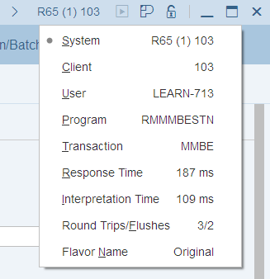
Choose to go back to the SAP Easy Access Menu.
Success-, Warning- and Error messages |  | Success-, Warning- and Error messages
The status bar shows information about the current system status as well as warning and error messages.

 | Step 3: Customize Local Layout
Task Use the menu to change user-specific settings. |  | Time 10 Min.
Choose More ► SAP GUI settings and actions and select Options. |  | Local Layout
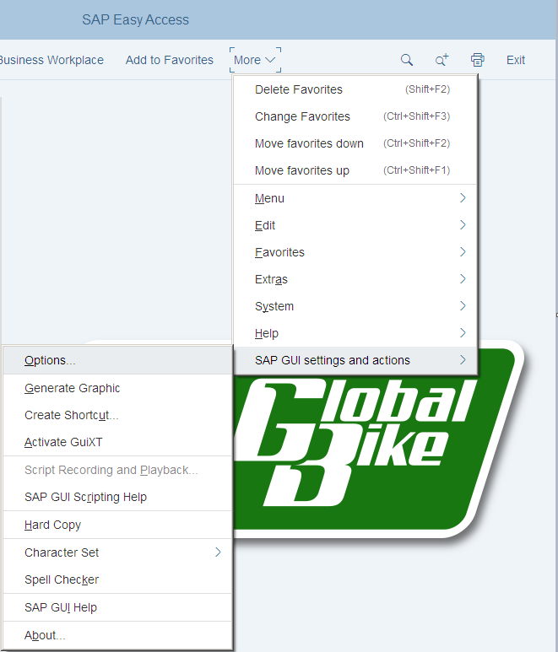
Within the new screen, expand Interaction Design and select Visualization 1. Activate the checkbox for Show keys within dropdown lists.
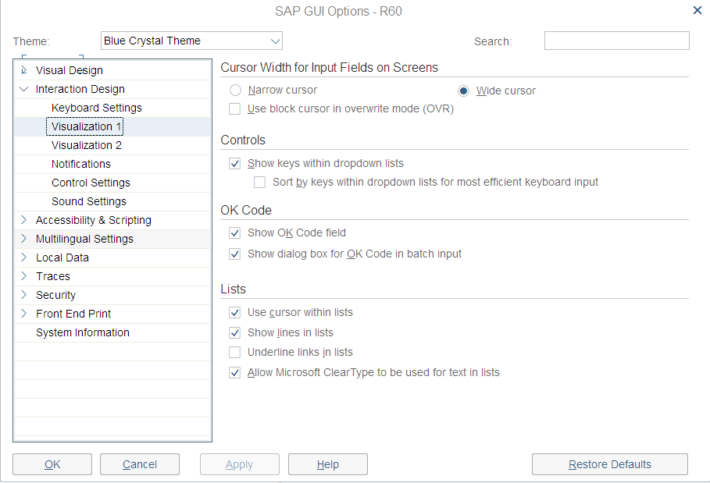
You can adjust warnings to not only show up within the status bar but within pop-ups as well. To do so, select the point Notifications and activate the respective checkboxes for showing success, warning and error messages in a dialog box.
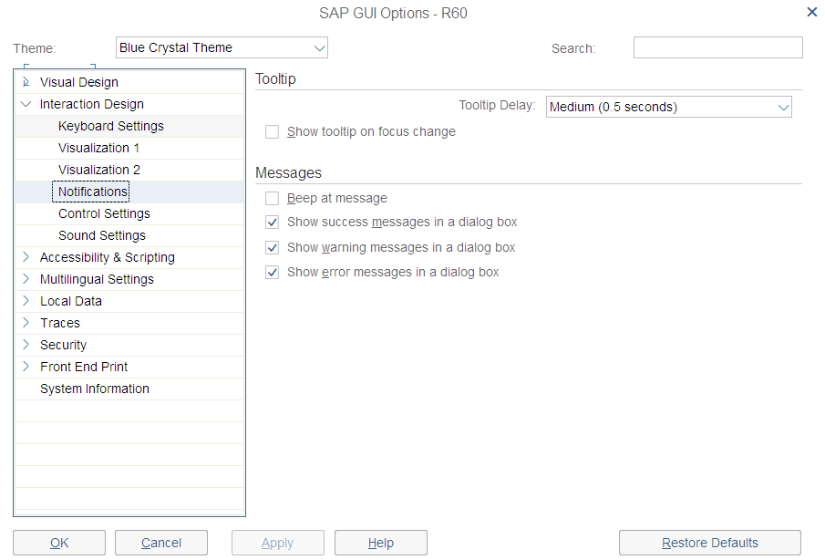
Press Ok to save your changes.
Now expand Visual Design and select Theme Preview/Settings.
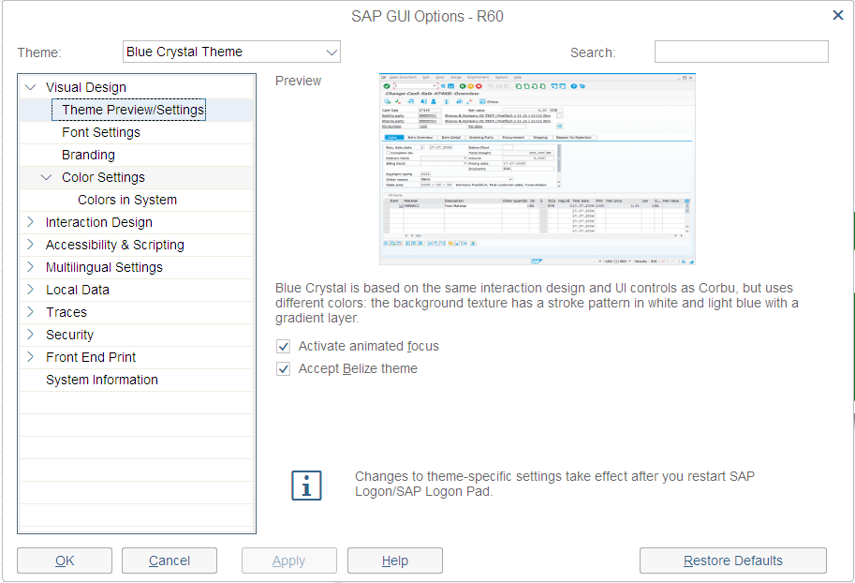 |  | This screen may look different. Instead, you will see Theme Settings where you can change the GUI Interface theme. You are encouraged to try it, but you can skip to Step 4.
The SAP GUI recognizes whether SAP-Fiori is activated on your system. If so, the GUI automatically takes the SAP Fiori theme. The Belize Theme checkbox is automatically selected.
By deselecting the checkbox there is the possibility to return to the old design. After you deselect the checkbox, click 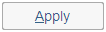 and then click . To activate the change, you must log on again. Click on and confirm the warning with Yes.
Now log in again with your user and password. As you can see, the surface has changed.
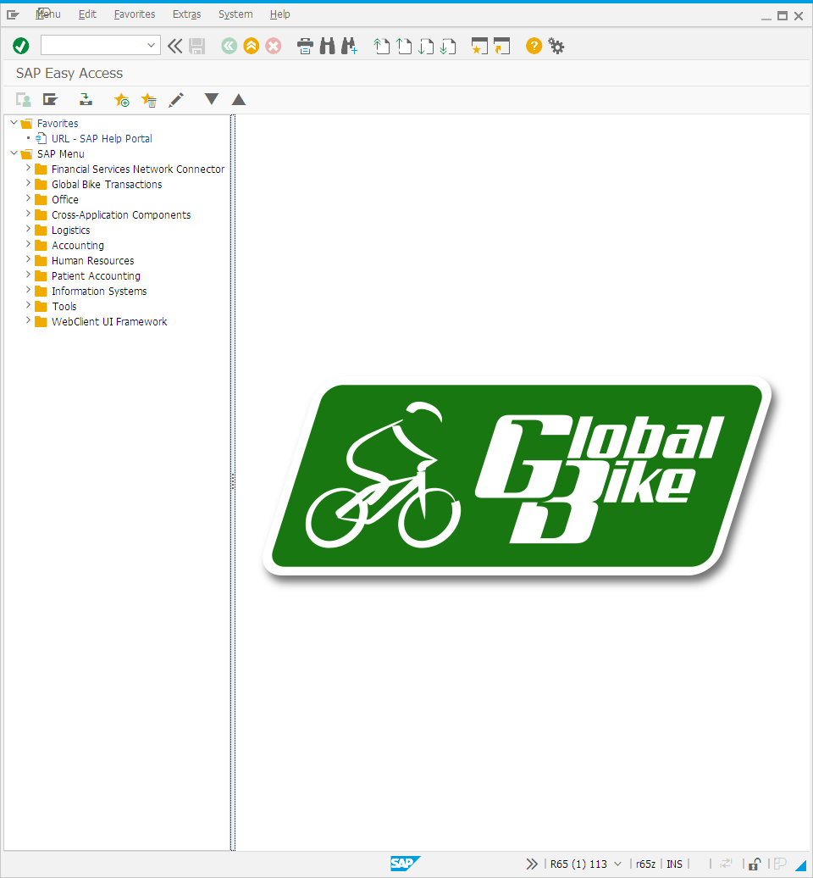
To undo the previous change, click and select Options.
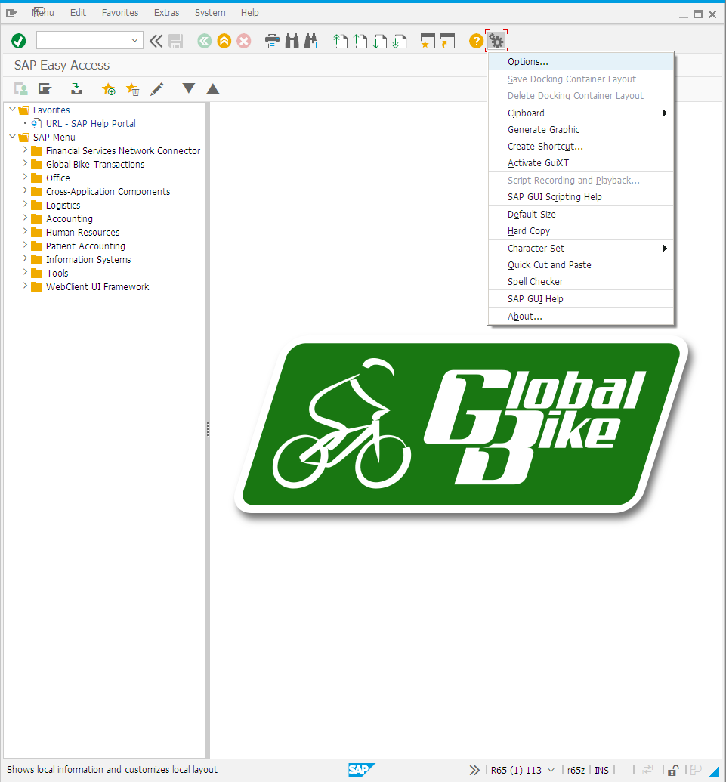
Expand Visual Design and choose Theme Preview / Settings. Select the Accept Belize theme check box.
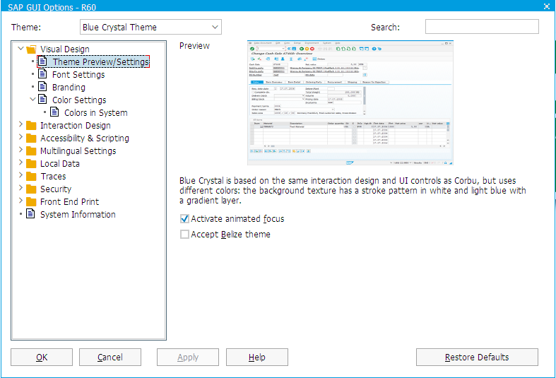
After that click and then . To activate the change, you must re-log on again.
Choose and confirm the pop-up with Yes.
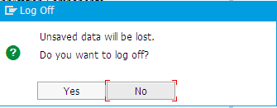
Now log on again. The new interface is displayed.

 | Step 4: Favorites
Task Create personal favorites.  Short Description Create your own favorites in SAP GUI and add objects to them. |  | Time 10 Min.
If you frequently use a transaction, you can use drag&drop to add it to your favorites (or choose Favorites ► Add). You can then double-click it to run it without having to navigate through the SAP Easy Access menu. Furthermore, you can add folders, reports, files and web addresses as favorites. |  | Other objects
By clicking Favorites with the right mouse button, you can create your own hierarchical folder structure.
You can add any link to your favorites, to do so click Favorites with the secondary mouse button. Choose Add other objects then Web Address or File. In the dialog box, enter a name and the URL shown below. To confirm choose .
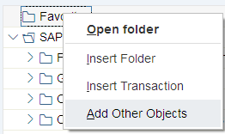
Exercise 2
Create/Expand your own favorites menu.
  - Add the SAP Help Portal using the URL help.sap.com.
  - Add the following transaction as a favorite:
Logistics ► Sales and Distribution ► Sales ► Order ► Display

 | Step 5: Transaction Codes
Task Get familiar with SAP transaction codes  Short description Learn how to effectively make use of SAP transaction codes and parameters. |  | Time 10 Min.
There are several possibilities to call up transactions in the SAP system. |  | Transaction Concept
The quickest way to run a transaction in the SAP system is to enter the transaction code. Every transaction has a code, which generally has four characters. |  | Transaction Code
SAP Easy Access Menu  By navigating through the SAP Easy Access Menu and using path structures you get to the transactions. Then double-click on the transaction to run it. |  | SAP Easy Access Menu
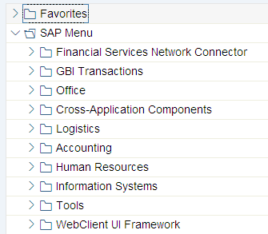
Transaction Code  Every business transaction (not every screen) has a corresponding transaction code in SAP. To display transaction codes, choose More ► Extras ► Settings and select Display technical names. |  | Transaction Code
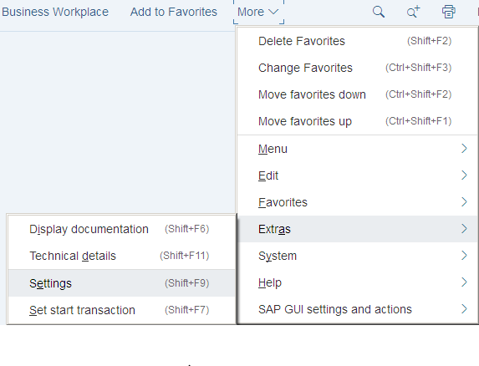
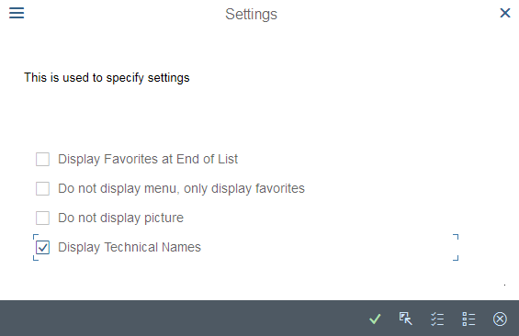
Note: The command field in which transaction codes are entered can be found on the upper left.
You can use various control parameters to influence what happens to the session when you call a transaction.
/n Exits the current transaction  /i Closes the current session  /o List of all modes (with option to delete and create new) |  | /n  /i  /o
It is also possible to use /o to open a transaction in a new mode. Assume that you are in the transaction Business Partner (BP) and want to open a new mode for the transaction Stock Overview (MMBE). To do this, enter the command field /oMMBE. After you have clicked Enter, a new mode opens with transaction MMBE.
There is the possibility to open several GUI windows in parallel. If you want to create a new GUI window, choose and then New GUI window.
To close a window, select in the upper right corner, press the Alt + F4 key combination or select and Close.
Exercise 3
  - What is the business process performed using transaction code VA03?
.
  - What is the business process performed using the menu path: Logistics ► Sales and Distribution ► Master Data ► Business Partner ► Customer ► Display ► Complete? What is the transaction Code?
.
  - Which transactional processes are performed using the following transaction codes?
XK03: .
MM02: .
ME23N: .
When leaving a transaction with you may be confronted with the displayed dialog box. Make sure that no unsaved data is visible in the current mode. Then select Yes.
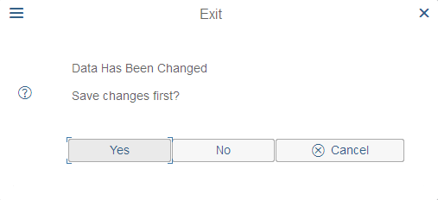

User specific settings
Using the command field enter transaction SU3 and switch to the Defaults tab. In this tab, general settings like Logon Language, Decimal Notation and Date Format can be determined for your user.
Please choose EN (English) for Logon Language, X 1,234,567.89 for Decimal Notation and MM/DD/YYYY as Date Format.

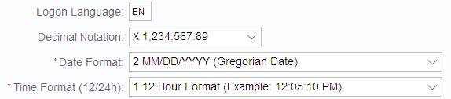
Save your entries using 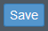.
Exercise 4 For the following exercise switch to transaction VA03, to do so leave the current transaction by using .
  - How many sessions can be open in the system in parallel? (Tip Click on the corresponding icon until the system does not create another session.)
.

 | Step 6: Help
Task Get familiar with SAP’s help functions.  Short Description Get familiar with help functions in SAP systems. Use the F1 and F4 help as well as the SAP Help Portal. |  | Time 10 Min.
Several types of help are available in the SAP system. The most frequently used ones are the F1 and F4 keys. |  | F1 and F4 help
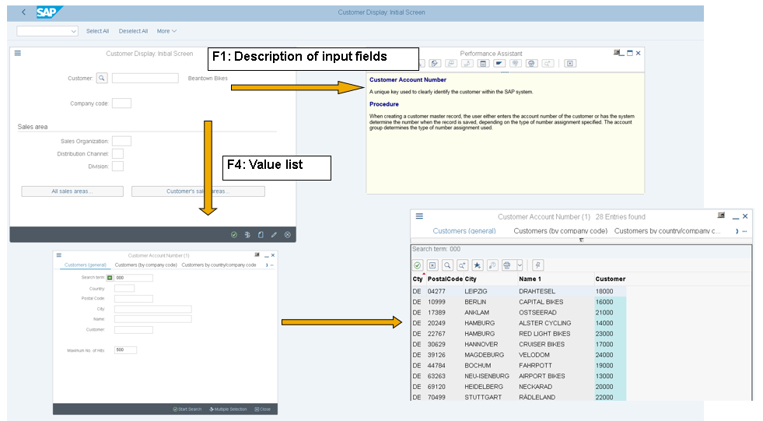
F1 provides you with explanations for fields, menus, functions, and messages. In the F1 help, you can choose to get technical information. |  | F1
F4 gives you information and possible entries. You can also use the F4 help by choosing directly to the right of a selected field. |  | F4
Further help can be found in the help menu. Choose Application Help or SAP Library to open the online SAP Library. You can also access it on the Internet at help.sap.com.
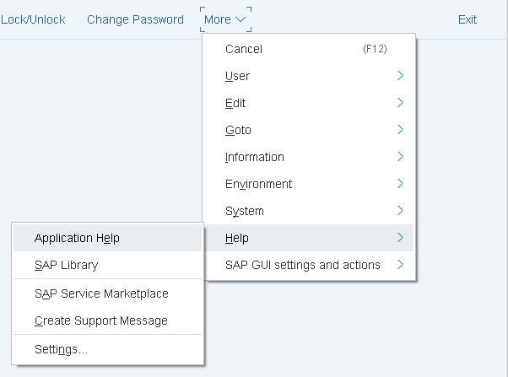
Exercise 5
  - Call up transaction VA01 and select the field Distribution Channel. Press the F1-button.
What is a distribution channel (in a few keywords)?
  - Close the window with definition of the Distribution Channel. Stay in transaction VA01. Click the field Order Type and press F4. What do the order types SO and OR stand for?
SO
OR
  - What is the difference between these two types of orders? (Use Application Help)

 | Step 7: Multiple Selection
Task Understand and perform multiple selection.  Short description Understand and perform multiple selection in SAP GUI and get to know useful hints about it. |  | Time 10 Min.
Choose transaction MMBE to get to the Stock Overview Screen. Display the stock from the plants in Dallas and Miami.
Please assure, that when you enter the two plants (DL00 and MI00) in the overview as shown below, you will not get the correct result.
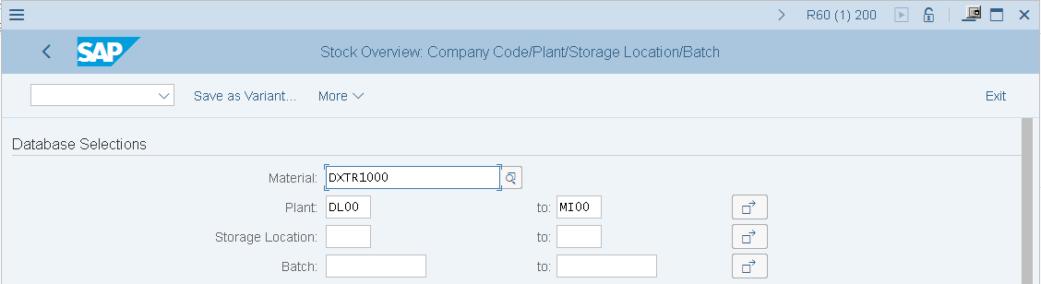
As you will see in the following screen, the plant in Heidelberg was chosen as well. This is due to the fact that the SAP system displays all plants which range alphabetically between DL00 and MI00.
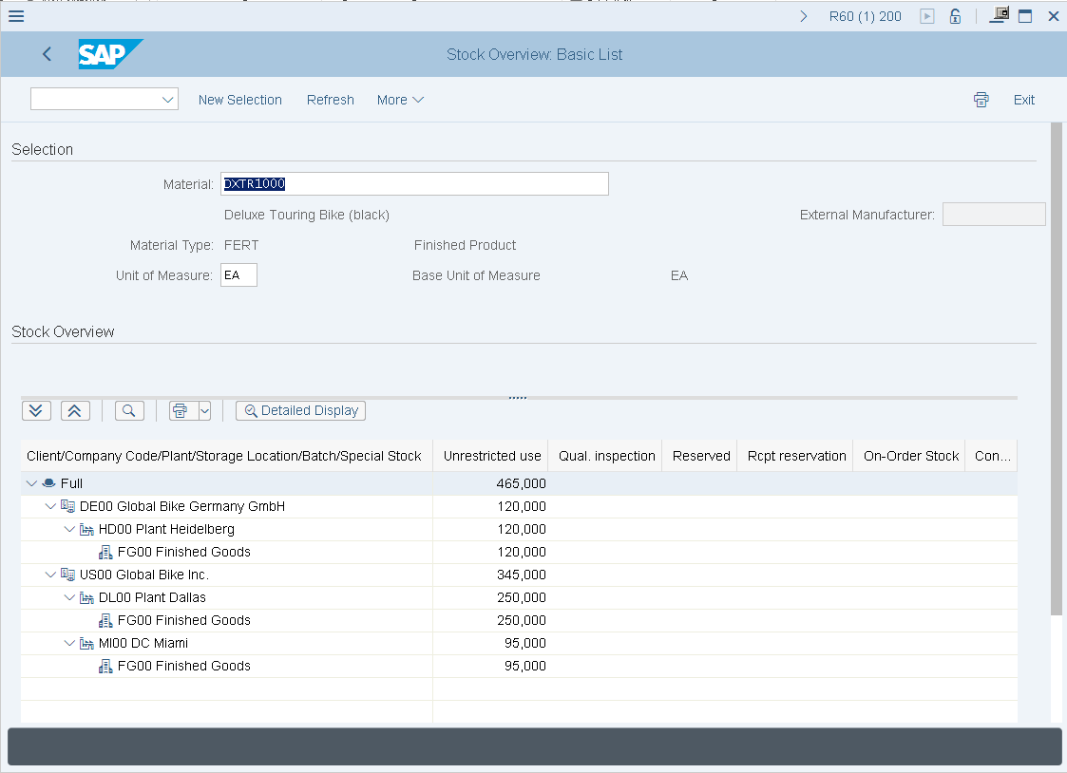
Therefore click to return to the last screen. Select the black Deluxe Touring Bike (DXTR1000) and click afterwards.  Choose multiple selection. Then choose the plants you want to display and press Enter or . |  | DXTR1000
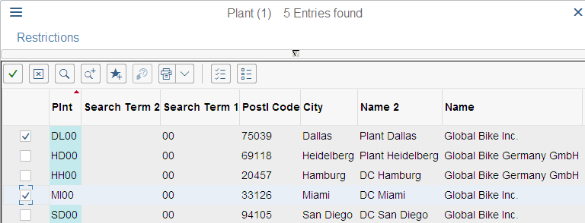
Afterwards select Execute and again .
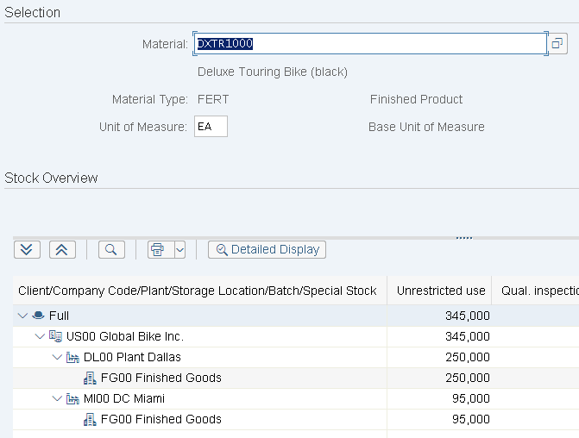

 | Step 8: Working at Global Bike Group
Task Display Global Bike information in SAP GUI.  Short Description Navigate through the SAP system to display the most important information of your enterprise in Global Bike. |  | Time 15 Min.
Exercise 6
  - How many black Deluxe Touring Bikes do you have in stock?
(Tip Therefore use transaction MMBE.)
  - Name the first customer in the search list?
Follow the menu path: Logistics ► Sales and Distribution ► Master Data ► Business Partner ► Customer ► Display ► Complete
(Hint Click on the field Customer and press F4. Search by Company Code. Then enter your Company Code as (DE00).
  - What is a debtor? (You don’t need the system to answer this)

 | Step 9: Logging Off
Task Log off the system.  Short Description Log off the SAP system. |  | Time 5 Min.
Choose to end the current session. The confirmation prompt shown on the right informs you that unsaved data will be lost. Once you are certain that you have saved all entries, you can confirm the prompt by choosing Yes. |  | Log Off
